

**PROJECT REPORT**

**ON**

**NEXUNITY**

**AS A PARTIAL REQUIREMENT FOR DEGREE**

**OF**

**BACHELOR OF COMPUTER APPLICATION**

**( B.C.A.)**

**: SUBMITTED BY : : GUIDED BY :**

**Jenil B Rangpariya**

**Divya I Jadav**

**ACKNOWLEDGEMENT**

This project would not have been possible without the kind support and help of many individuals and institutions.I would like to extend my sincere thanks to Sutex Bank College of Computer Applications & Science for giving me permission to do project work in their Organization.

I am highly indebted to Asst Prof.Ankit J.Rabadiya for their guidance and constant supervision as well as for providing necessary information regarding the project & also for their support in completing the project.

I would like to express my gratitude towards my parents & member of (Organization Name) for their kind co-operation and encouragement which help me in completion of this project.

I would like to express my special gratitude and thanks to industry persons for giving me such attention and time.

My thanks and appreciations also go to my colleague in developing the project and people who have willingly helped me out with their abilities.

**INDEX**

|  |  |
| --- | --- |
| **Chapter** | **Page No.** |
| 1. **Introduction**    1. Project description    2. Project profile | 5 |
| **2. Environment Description**  2.1 Hardware and Software Requirements  2.2 Technologies Used [Max 2 pages] | 10 |
| **3. System Analysis and Planning**  3.1 Existing system and its Drawbacks  3.2 Feasibility Study  3.3 Requirement Gathering and Analysis | 17 |
| **4. Proposed System**  4.1 Scope  4.2 Project Modules  4.3 Modulewise Objectives / Functionalities Constraints  4.4 Expected Advantages | 25 |
| **5. Detail Planning**  5.1 Data Flow Diagram / UML  5.2 Process Specification / Activity Flow Diagram  5.3 Data Dictionary  5.4 Entity-Relationship Diagram / Class Diagram | 31 |
| **6. System Design**  6.1 Database Design  6.2 Directory Structure  6.3 Input Design  6.4 Output Design | 49 |
| **7. Software Design** | 87 |
| **8. Limitations and Future Scope of Enhancements References** | 91 |

|  |
| --- |
| ***1. Introduction*** |

* 1. ***Project Description***
  2. ***Project Profile***
* Well, our site name is NexUnity. The meaning of NexUnity is upcoming generation and community.

* The main purpose behind creating this project is that people of the community can communicate and engage each other easily by using digital interactions .
* NexUnity has many features same as other social medias. It provides many features, such as : communication, sharing, and collaboration within these familial networks. Users can engage with one another through messaging, sharing updates, photos, and memories, strengthening bonds across generations and geographical distances.
* Additionally, User as well as Admin have authority to create “ Community Account “ .
* Moreover ,in this site not contains only other social media features but also used some advanced features , For instance : News , Events , Jobs , and so on.

|  |
| --- |
| ***1.1 Project Description*** |

|  |
| --- |
| ***1.2 Project Profile*** |

|  |  |
| --- | --- |
| Project Type : | Website |
| Project Title : | NexUnity |
| Front End : | ReactJS , JavaScript |
| Back End : | NodeJS, TypeScript, ExpressJS |
| Data Base: | MongoDB |
| Internal Guide : |  |
| Submitted To : | Prabhu BCA College |
| Developed By: | Jenil B Rangpariya  Divya I Jadav |

|  |
| --- |
| ***2. Environment Description*** |

***2.1 Hardware And Software***

***Requirements***

* 1. ***Technologies Used***

|  |
| --- |
| ***2.1 Hardware And Software Requirement*** |

|  |
| --- |
| **Hardware Requirements :** |
| Hard Disk 100GB |
| RAM 4GB |
| Processor Intel core i5 or Higher |

|  |
| --- |
| **Software Requirements :** |
| Operating system : Windows10 pro |
| Web Browser : Chrome , Internet Explorer |
| Database : MongoDB |
| Tools : VS code |

|  |
| --- |
| ***2.2 Technologies Used*** |

* ***Front End :***



* ***What is React?***
* *React, sometimes referred to as a frontend JavaScript framework, is a JavaScript library created by Facebook.*
* *React is a tool for building UI components.*
* *ReactJS is a JavaScript library for building user interfaces, maintained by*

*Facebook and several individual developers/companies.*

* *It is a popular, open-source, front-end JavaScript library that is prominent in the web development domain, especially for single-page applications. It is widely used to create fast and interactive UI elements for web and mobile apps.*
* *ReactJS is also represented as* ***React or React.js.*** *Many organizations mainly Fortune 500 companies have been preferring ReactJS because of its salient features.*
* *It facilitates developers to build large web apps that can change the data without page reloading. It can seamlessly work as a fusion with other JavaScript libraries like AngularJS.*
* React has been designed from the start for gradual adoption and **we can use as little or as much React as we needs.** Whether we want to get a taste of React, add some interactivity to a simple HTML page,or start a complex React-powered app .
* ***ReactJs :***
* ***JavaScript :***



* ***What is JavaScript?***
* JavaScript is the world's most popular programming language.
* JavaScript is the programming language of the Web.
* JavaScript is easy to learn.
* JavaScript is a versatile, lightweight, client-side scripting language used in web development.
* It can be used for both Client-side as well as Server-side developments. JavaScript is also known as a scripting language for web pages, It supports variables, data types, operators, conditional statements, [loops](https://www.geeksforgeeks.org/loops-in-javascript/), functions, [arrays](https://www.geeksforgeeks.org/javascript-arrays/), and [objects](https://www.geeksforgeeks.org/objects-in-javascript/). With JavaScript, you can create dynamic, interactive, and engaging websites.
* JavaScript Variables are the building blocks of any programming language. In JavaScript, variables can be used to store reusable values.
* ***Back End :***
* ***NodeJs:***



Page 9

* ***What is Node.js?***
* *Node.js is an open source server environment .*
* *Node.js is free.*
* *Node.js runs on various platforms (Windows, Linux, Unix, Mac OS X, etc.)*
* *Node.js uses JavaScript on the server.*
* *Node.js is an open-source, cross-platform, back-end JavaScript runtime environment that runs on the V8 engine and executes JavaScript code outside a web browser.*
* *Node.js lets developers use JavaScript to write command line tools and for server-side scripting—running scripts server-side to produce dynamic web page content before the page is sent to the user's web browser.*
* *Consequently, Node.js represents a "JavaScript everywhere" paradigm, unifying web-application development around a single programming language, rather than different languages for server- side and client-side scripts.*
* *Node.js has an event-driven architecture capable of asynchronous I/O. These design choices aim to optimize throughput and scalability in web applications with many input/output operations, as well as for real-time Web applications .*



* **What is ExpressJS :**
* Express.js, or simply Express, is a back end web application framework for Node.js, released as free and open-source software under the MIT License.
* It is designed for building web applications and APIs. It has been called

the de facto standard server framework for Node.js.

* The original author, TJ Holowaychuk, described it as a Sinatra-inspired server, meaning that it is relatively minimal with many features available as plugins.
* Express is the back-end component of popular development stacks like the MEAN, MERN or MEVN stack, together with the MongoDB database software and a JavaScript front-end framework or library.
* [***E***](https://expressjs.com/)***xpressJs :***
* ***TypeScript :***



* **What is TypeScript :**
* TypeScript is JavaScript with added syntax for types.
* TypeScript was first announced by Microsoft in October 2012, with Anders Hejlsberg, the creator of C# and Turbo Pascal, leading the project.
* As TypeScript is a strict superset of JavaScript, it retains compatibility with existing JavaScript code.
* The TypeScript compiler (tsc) transpiles TypeScript code to JavaScript, allowing it to run in any environment that supports JavaScript.
* This ensured that developers could gradually adopt TypeScript in their projects without having to rewrite their entire codebase.

Page 11

|  |
| --- |
| ***3. System Analysis And Planning*** |

* 1. ***Existing System And its Drawbacks***
  2. ***Feasibility Study***
  3. ***Requirement Gathering And Analysis***

|  |
| --- |
| ***3.1 Existing System And its Drawbacks*** |

* **Existing System :**
* In the existing system for messaging websites, users typically visit specific platforms to communicate with their contacts.
* If a user wishes to message different contacts across various messaging websites, they often need to register separately for each website.
* Confirmation of messages may be required depending on the website's functionalities, and if the messaging website lacks its own dedicated application, users may resort to third-party applications for messaging purposes.

­­­­­­

* **Drawbacks :**

In the existing system of messaging websites:

* Users need to visit specific messaging platforms individually to communicate with their contacts, resulting in fragmentation.
* To message different contacts across various messaging websites, users are required to register separately for each platform, leading to inconvenience and duplication of efforts.
* Users are constrained to visit specific messaging websites for communication, limiting flexibility and convenience.
* Finding the most suitable messaging website for online communication purposes can be time-consuming as users navigate through various platforms.
* When users travel to new locations, they may struggle to identify the most optimal messaging website available in their current vicinity, causing inconvenience and potential communication barriers.

Page 14

|  |
| --- |
| ***3.2 Fesibility Study*** |

The measure of how beneficial or practical the development of informant system will be to an organization. Along this topic feasibility is measured. So far taking the feasibility study and feasibility analysis during the development of the project Online Food Ordering System we have studied on the following four major categories of feasibility study.

1. Operational Feasibility
2. Technical Feasibility
3. Schedule Feasibility
4. Economic Feasibility

1. Operational Feasibility:

* We have evaluated how well the project will support both users and service providers during its operational phase.
* This involves assessing whether the website will be feasible to operate effectively.

2. Technical Feasibility:

* We have analyzed the practicality and availability of technical resources and expertise required for the website.
* This includes assessing the practicality of the proposed technology solution and determining if we possess the necessary technical capabilities.

3. Schedule Feasibility:

* We have measured the reasonableness of the project's timetable and deadlines.
* It is crucial to ensure that the project can be completed within the allocated time frame, especially when faced with time constraints.

4. Economic Feasibility:

* We have conducted a cost-benefit analysis to determine the cost-effectiveness of the project.
* This involves identifying user requirements and evaluating alternative technical solutions to ensure that the project is economically viable.

Page 13

|  |
| --- |
| ***3.3 Requirement Gathering And Analysis*** |

**\*Observation\***

* We extensively observed various social media platforms in action, such as Facebook, Twitter, Instagram, etc., as users. This allowed us to understand the functionalities they offer, user interactions, and the overall user experience.

**\*Interviews\***

* We conducted interviews with social media platform owners, administrators, and active users to gain insights into the functionalities they find most useful, challenges they face, and features they wish to have. These interviews provided valuable firsthand information about managing user profiles, content creation, interaction mechanisms, privacy settings, and other essential aspects of social media platforms.
* By combining these methods, we were able to gather comprehensive requirements and insights into user expectations, which guided us in designing the system functionalities. Based on this gathered data, we decided to incorporate the following modules into our social media website:

1. **User Profiles**:

* Providing users with customizable profiles to express themselves and connect with others.

1. **Content Creation and Sharing**:

* Enabling users to create and share various types of content, such as posts, photos, videos, and stories.

1. **Interactions**:

* Facilitating user interactions through features like likes, comments, shares, direct messaging, and group chats.

1. **Privacy and Security**:

* Implementing robust privacy settings and security measures to protect user data and ensure a safe online environment.

1. **Analytics and Insights**:

* Offering users and administrators access to analytics and insights to track engagement, audience demographics, and performance metrics.

1. **Notifications**:

* Keeping users informed about relevant activities, such as new followers, likes, comments, and messages.

1. **Search and Discovery**:

* Providing users with tools to discover new content, people, and communities based on their interests and preferences.
* By focusing on observation and interviews, we were able to tailor our social media website to meet the needs and expectations of our target audience effectively.

Page 14

|  |
| --- |
| ***4 .Proposed System*** |

* 1. ***Scope***
  2. ***Project Modules***

***4.3*** ***Expected Advantages***

|  |
| --- |
| ***4 .1 Scope*** |

The primary objective of the Social Media Website is to enhance user satisfaction by providing a platform for seamless social interaction and content sharing. The system enables users to engage with their desired content and connections within minutes, fostering a convenient and enjoyable social media experience.

The Social Media Website serves as a hub for users to connect with friends, family, and communities, as well as discover new content and interests. Users can easily search for specific users, groups, or topics of interest within the platform.

The main goal of our system is to streamline social interactions and content sharing across multiple users, without the need to navigate through various platforms. Our platform caters to users worldwide, ensuring accessibility and inclusivity for a diverse user base.

* **Key features of the Social Media Website include :**

- Users can interact with a wide range of content and connections from different users and pages.

- The platform facilitates seamless communication and engagement between users and their social circles.

- Users can manage their profiles, connections, and content within the platform.

- Robust security measures are implemented to safeguard user data and ensure secure authentication for members.

- The platform prioritizes user privacy, limiting access to sensitive information and ensuring confidentiality.

- Effortless registration and onboarding processes are provided to welcome new members and facilitate their integration into the platform's community.

By focusing on user satisfaction and convenience, our Social Media Website aims to redefine the way users engage with social media, offering a comprehensive and user-friendly platform for social interaction and content sharing.

Page 15

|  |
| --- |
| ***4.2 Project Modules*** |

* **In this project there are two modules which have various functionalities which are given below.**
* ***Module wise Objectives:***

|  |
| --- |
| 1. ***Admin*** |

* Objectives of admin are described below :
  + Login
  + Registration
  + Manage user
  + Forget password
  + Edit profile
  + Manage profile history
  + Message

|  |
| --- |
| ***2. User :*** |

* Objectives of user are described below :
  + - Login
    - Registration
    - Forget password
    - Edit profile
    - Manage profile
    - Meassage

|  |
| --- |
| ***4 .3 Expected Advantages*** |

* ***Convenient for Users:***

- Users can access the social media website conveniently using their mobile devices, allowing them to stay connected on the go.

- Whether at home, on public transportation, or any other location, users have the flexibility to engage with the platform at their convenience.

* ***No Frustration:***

- Users experience minimal frustration with the social media website as there are no queues or waiting times to access content or interact with others.

- Unlike traditional social gatherings or events, there are no restrictions on the number of participants or physical barriers to communication, reducing frustration associated with limited access.

* ***Cost-Effective:***

- Engaging with the social media website incurs little to no cost for users, making it an economical option for staying connected and entertained.

- Compared to expenses associated with traditional social activities such as dining out or attending events, online interaction via the social media website offers significant cost savings.

* ***Fast and Efficient Interaction:***

- Users receive instant notifications of new content or interactions, ensuring swift and efficient communication with friends, family, and followers.

- The platform facilitates quick response times and seamless interaction, enhancing the overall user experience.

* ***Reduced Manual Effort:***

- Users can engage with various social media activities, such as posting updates, sharing content, and interacting with others, without the need to navigate multiple applications or platforms.

- The social media website streamlines communication and content sharing processes, minimizing the need for manual effort and simplifying user interaction.

|  |
| --- |
| ***5. Details Planning*** |

***5.1 Data Flow Diagram***

***5.2 Process Specification***

***5.3*** ***Data Dictionary***

***5.4 Entity-Relationship Diagram***

|  |
| --- |
| ***5.1 Data Flow Diagram*** |

* **0 Level Diagram (Contex Diagram) :**

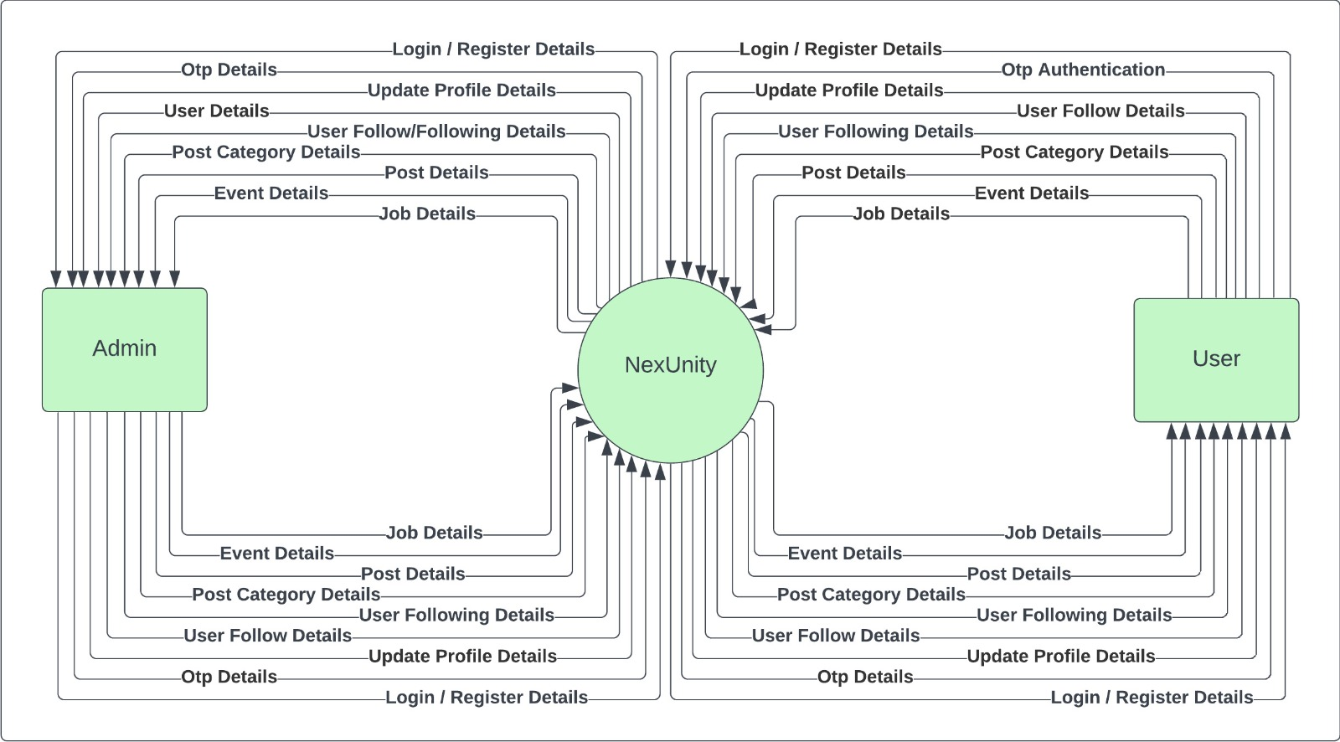

* **1st Level Admin Diagram :**

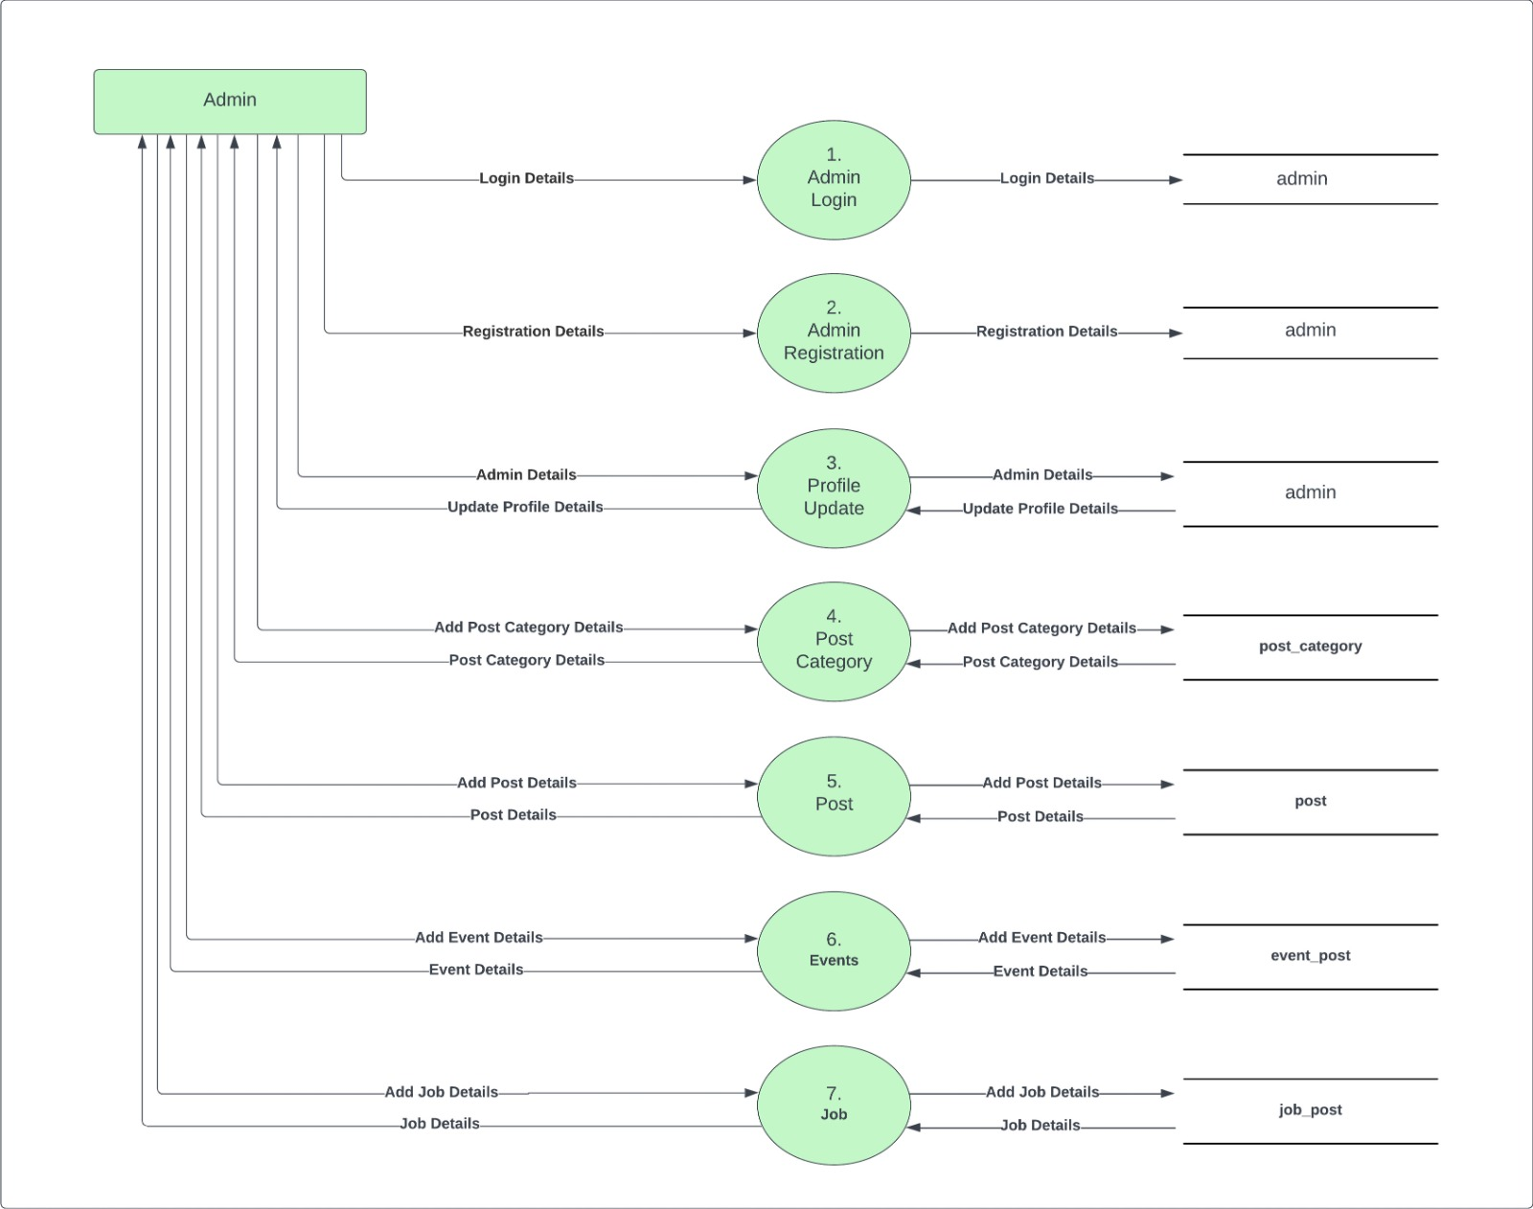

* **1st Level User Diagram :**

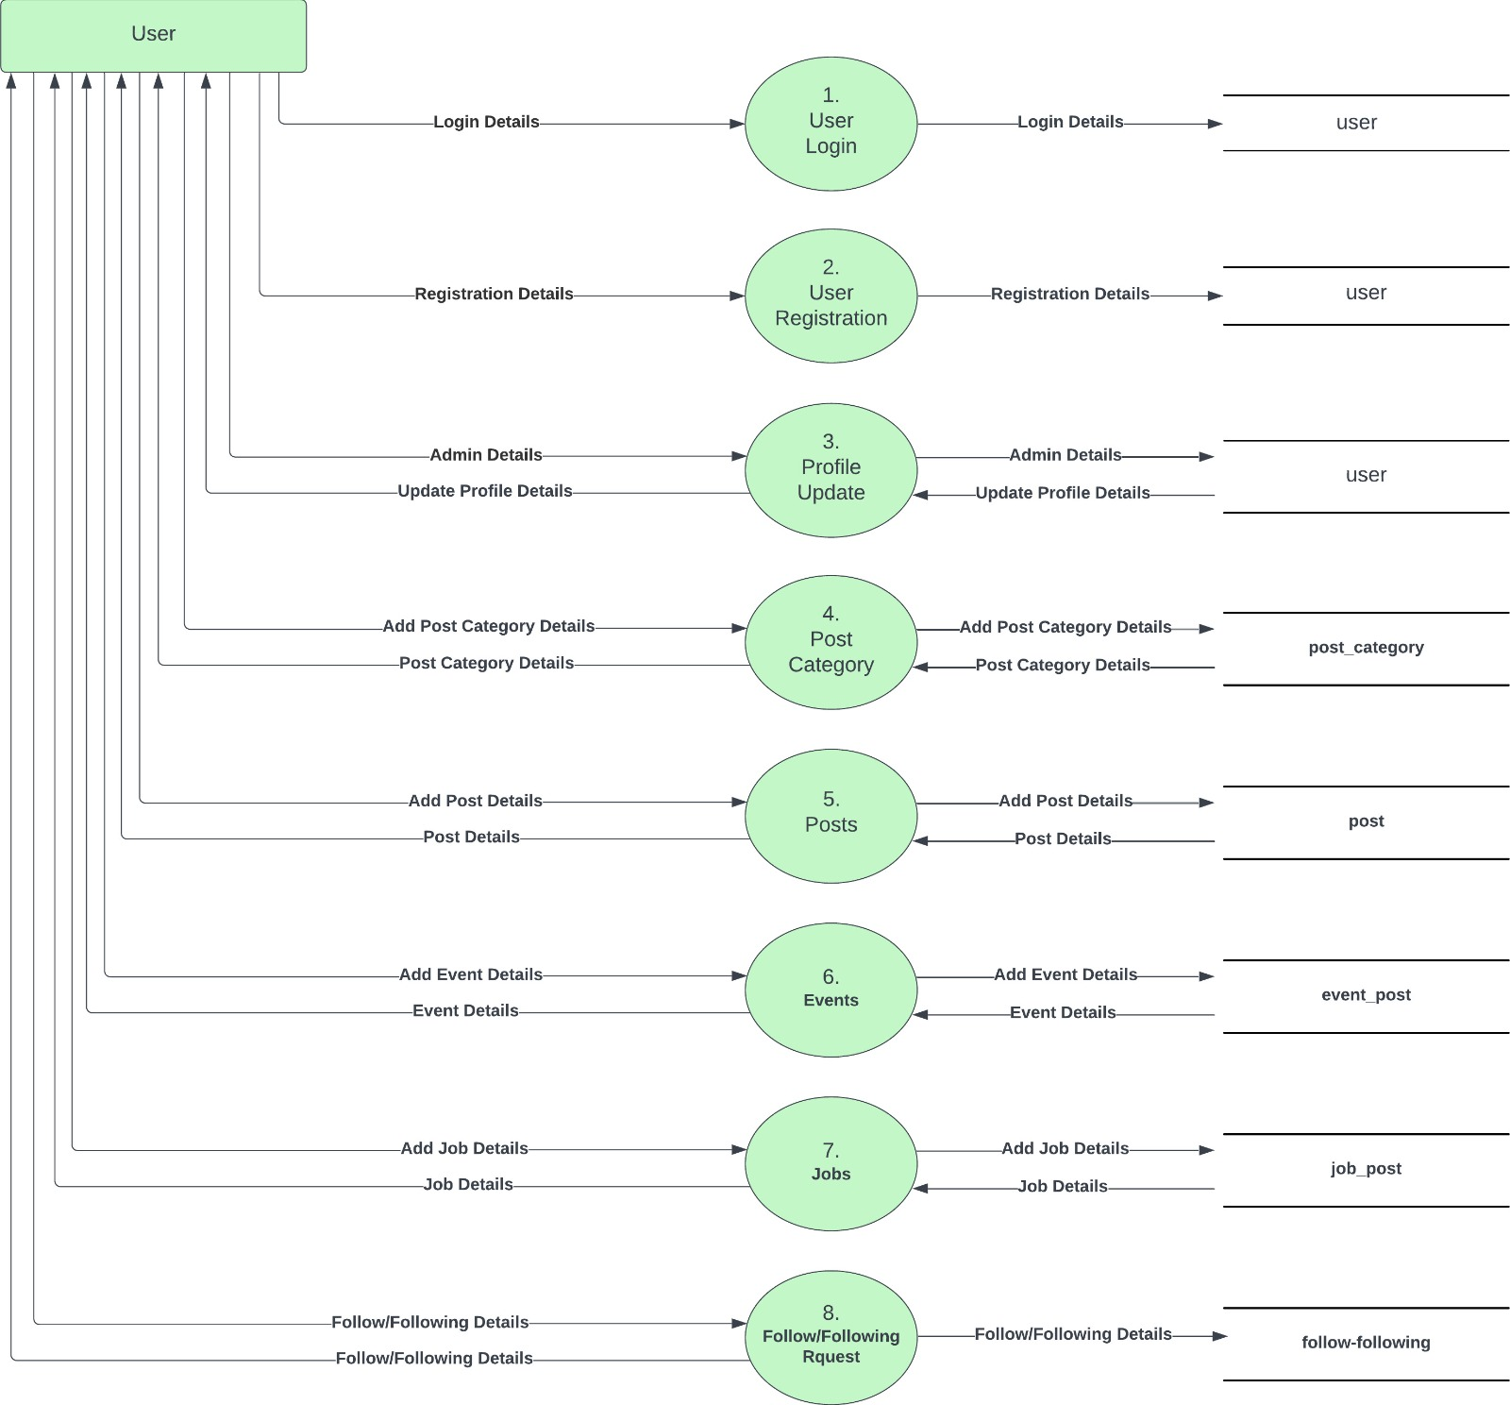

* **2nd Level Admin Diagram :**

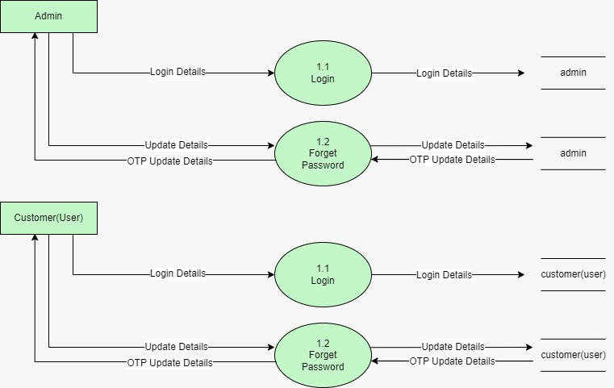

* **2nd Level User Diagram :**



* **2nd Level User Diagram :**

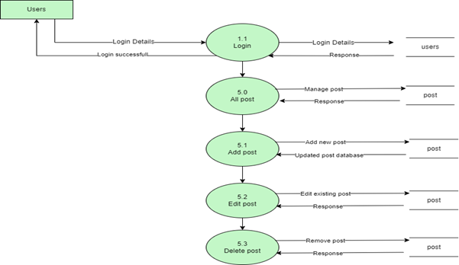

* 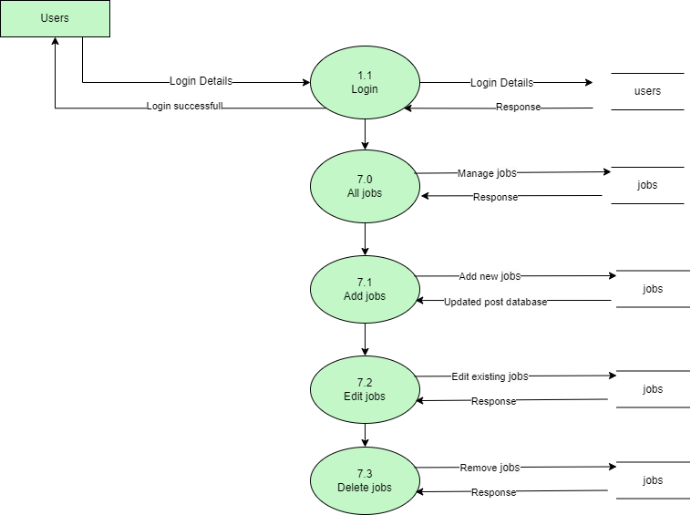**2nd Level User Diagram :**
* **2nd Level Admin Diagram :**

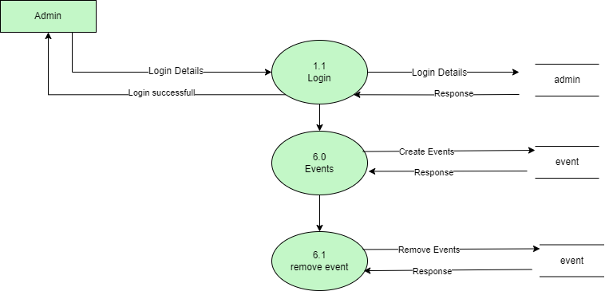

* **2nd Level Admin Diagram :**

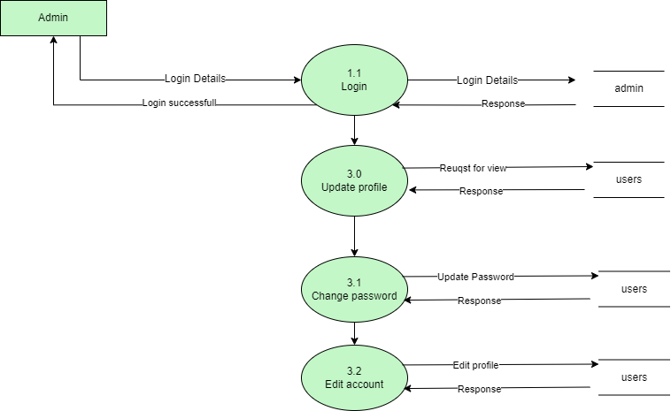

|  |
| --- |
| ***5.2 Process Specification*** |

* **Registration Admin Process :**

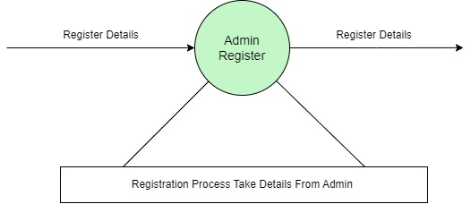

* **Login Admin Process :**

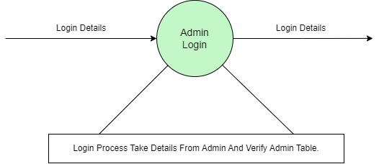

* **Profile Update (Admin,User) Process :**

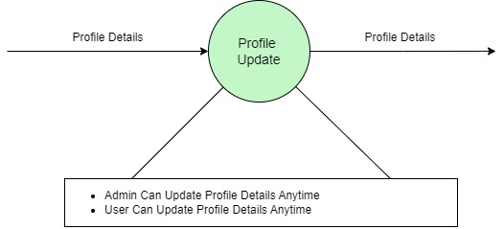

* **Forget Password (Admin,User) Process:**

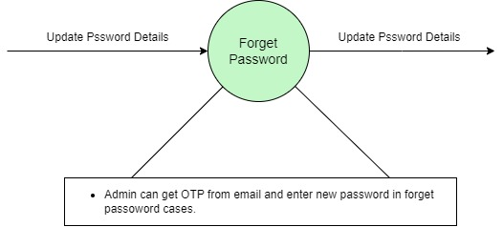

* **Register User Process :**

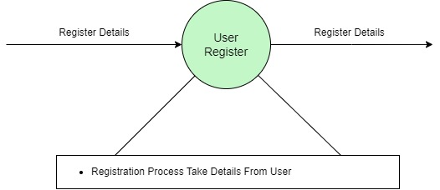

* **Login User Process :**

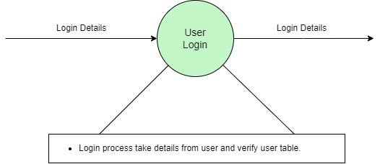

|  |
| --- |
| ***5.3 Data Dictionary*** |

|  |  |
| --- | --- |
| Name: | Login detail |
| Alias: | Null |
| Where used? / How used? | Admin Login(Input/Output) |
| Content Description: | email,password |
| Supplementary Information: | Admin can log in to access the application. The login process requires users to provide their login details |

|  |  |
| --- | --- |
| Name: | Update password detail |
| Alias: | Null |
| Where used? / How used? | Update password(forgot password) (Input/Output) |
| Content Description: | Email, password |
| Supplementary Information: | Admin can get OTP from their Email and enter new password in forgot password cases.  User can get OTP from their Email and enter new assword in forgot password cases.. |

|  |  |
| --- | --- |
| Name: | Registration detail |
| Alias: | Null |
| Where used? / How used? | Admin/User Registration (Input/Output) |
| Content Description: | first_name,middle_name,surname,gender,email,password,profile_pic,token,isPrivate,role,isRoot,active |
| Supplementary Information: | Admin/User can registration for using the Application. Registration Process take detail from admin. |

|  |  |
| --- | --- |
| Name: | Profile detail |
| Alias: | Null |
| Where used? / How used? | Profile update (Input/Output) |
| Content Description: | first_name,middle_name,surname,gender,isPrivate,profile_pic |
| Supplementary Information: | Admin can Update Profile Details Anytime.  User can Update Profile Details Anytime. |

|  |  |
| --- | --- |
| Name: | Post detail |
| Alias: | Null |
| Where used? / How used? | Post (Input/Output) |
| Content Description: | createUserId,category_id,communityId,content,image,post_type |
| Supplementary Information: | Admin can Add & Update Post Details Anytime.  User can Add & Update Post Details Anytime. |

|  |  |
| --- | --- |
| Name: | Post category |
| Alias: | Null |
| Where used? / How used? | Post category (Input/Output) |
| Content Description: | category_name |
| Supplementary Information: | Admin can Add & Update Post category Details Anytime.  User can Add & Update Post category Details Anytime. |

|  |  |
| --- | --- |
| Name: | Event detail |
| Alias: | Null |
| Where used? / How used? | Event (Input/Output) |
| Content Description: | createUserId,eventName,content,time,location,eventImage |
| Supplementary Information: | Admin can Add & Update Event Details Anytime.  User can Add & Update Event category Details Anytime.. |

|  |  |
| --- | --- |
| Name: | Job detail |
| Alias: | Null |
| Where used? / How used? | Job (Input/Output) |
| Content Description: | companyName,content,title,jobImage |
| Supplementary Information: | Admin can Add & Update Job Details Anytime.  User can Add & Update Job Details Anytime. |

|  |  |
| --- | --- |
| Name: | Job Applicant detail |
| Alias: | Null |
| Where used? / How used? | Job Applicant (Input/Output) |
| Content Description: | id,fullName,experience,description,email |
| Supplementary Information: | User can Job Apply Anytime. |

|  |  |
| --- | --- |
| Name: | Post Like detail |
| Alias: | Null |
| Where used? / How used? | Post Like (Input/Output) |
| Content Description: | userId,postId |
| Supplementary Information: | User Can Post Like Anytime. |

|  |  |
| --- | --- |
| Name: | Post Comment detail |
| Alias: | Null |
| Where used? / How used? | Post Comment (Input/Output) |
| Content Description: | userId,postId,content |
| Supplementary Information: | User Can Post Comment Add ,Update ,Delete Anytime. |

|  |  |
| --- | --- |
| Name: | Follow & Following detail |
| Alias: | Null |
| Where used? / How used? | Follow & Following (Input/Output) |
| Content Description: | fromUserId,toUserId,isActive |
| Supplementary Information: | User Can Follow And Following To Other User Anytime. |

|  |  |
| --- | --- |
| Name: | Follow & Following detail |
| Alias: | Null |
| Where used? / How used? | Follow & Following (Input/Output) |
| Content Description: | fromUserId,toUserId,isActive |
| Supplementary Information: | User Can Follow And Unfollow To Other User Anytime. |

|  |  |
| --- | --- |
| Name: | Community detail |
| Alias: | Null |
| Where used? / How used? | Community (Input/Output) |
| Content Description: | communityId,userId,role |
| Supplementary Information: | User Can Create Community And Join Also Join Other Community |

|  |
| --- |
| ***5.4 Entity Relationship Diagram*** |

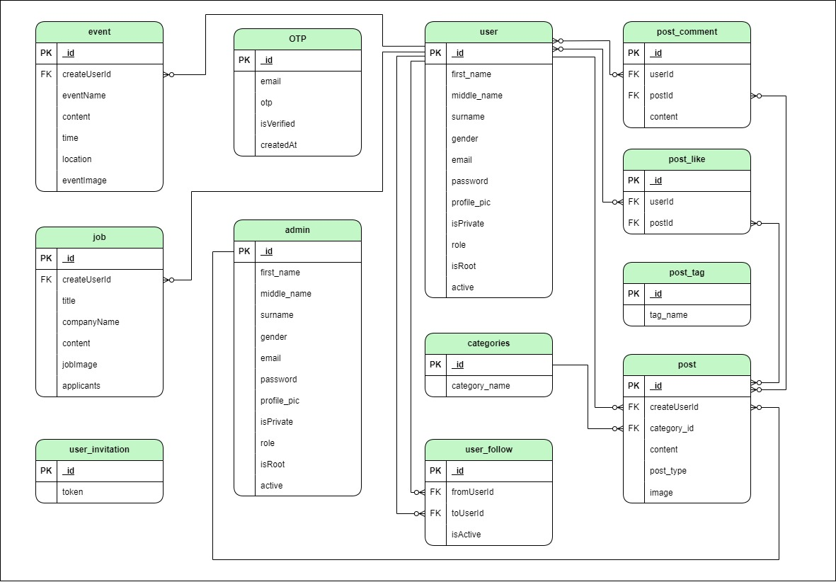

|  |
| --- |
| ***6. System Design*** |

***6.1 Database Design***

***6.2 Directory Structure***

***6.3 Input Design***

***6.4 Output Design***

|  |
| --- |
| ***6.1 Database Design*** |

* **Event table :**

|  |  |  |  |
| --- | --- | --- | --- |
| ***Field Name*** | ***Type*** | ***Constraint*** | ***Description*** |
| **createUserId** | *ObjectId* | *Unique, Require* | *Used for storing data for event* |
| ***eventName*** | *String* | *Require* | *Name of event* |
| ***content*** | *string* | *Unique, Require* | *Content of event* |
| ***Time*** | *Date* | *Require* | *Time for event* |
| ***location*** | *String* | *Require* | *Location of event* |
| ***eventImage*** | *String* | *Require* | *Event Images* |

|  |  |  |  |
| --- | --- | --- | --- |
| **Field Name** | **Data Type** | **Constraint** | **Description** |
| **first_name** | String | Require | For storing user details |
| **middle_name** | String | Require | For storing user details |
| **surname** | String | Require | For storing user details |
| **gender** | Number | Default | Gender details |
| **email** | String | Require ,Trim ,Unique | Email address |
| **password** | String | Require | Password details. |
| **profile_pic** | String |  | Profile picture of user |
| **isPrivate** | Boolean | Require | Check private or public |
| **Role** | Number | Default |  |
| **isRoot** | Boolean | Default |  |
| **active** | Boolean | Default |  |

* **User table :**
* **User follow :**

|  |  |  |  |
| --- | --- | --- | --- |
| **Field Name** | **Type** | **Constraint** | **Description** |
| **fromUserId** | *ObjectId* | *Require* | Use to store details about followers and followings |
| **toUserId** | *ObjectId* | *Require* | *_id from users collection* |
| **isActive** | *Boolean* | *Require,Default* | request is accepted or not |

* **OTP table :**

|  |  |  |  |
| --- | --- | --- | --- |
| **Field Name** | **Type** | **Constraint** | **Description** |
| **Email** | *String* | *Require* | *for storing otp* |
| **Otp** | *Number* | *Require* | Send in email |
| **isVerified** | *Boolean* | *Require* | Email verified |
| **createdAt** | *Date* | *Default* | *it store otp for 5 minute and then it will auto-delete* |

* **Post Like :**

|  |  |  |  |
| --- | --- | --- | --- |
| **Field Name** | **Type** | **Constraint** | **Description** |
| **userId** | *ObjectId* | *Require* | Use for storing data about number of people like a particular post |
| **postId** | *ObjectId* | *Require* | who like that post |

* **Job Table :**

|  |  |  |  |
| --- | --- | --- | --- |
| **Field Name** | **Type** | **Constraint** | **Description** |
| **createUserId** | *ObjectId* | *Unique ,Require* | *Use to store details about job post* |
| ***Title*** | *String* | *Require* | Title of job |
| ***companyName*** | *String* | *Unique, Require* | *Name of company* |
| ***content*** | *String* | *Require* | *Content of particular job* |
| **jobImage** | *String* | *Require* | *Image for apply job* |
| ***applicants*** | *Number* | *Default* | *Applicants of user* |

* **Post Categories Table :**

|  |  |  |  |
| --- | --- | --- | --- |
| **Field Name** | **Type** | **Constraint** | **Description** |
| **category_name** | *String* | *Unique*  *,Require* | *Use to store post categories* |

* **User Invitation Table :**

|  |  |  |  |
| --- | --- | --- | --- |
| **Field Name** | **Type** | **Constraint** | **Description** |
| **token** | *String* | *Unique*  *,Require* | *Use to store details about user invitations* |

* **Post Tag Table :**

|  |  |  |  |
| --- | --- | --- | --- |
| **Field Name** | **Type** | **Constraint** | **Description** |
| **tag_name** | *String* | *Unique*  *,Require* | *Use to store details about new hastag that is used by users in their post and help them to see when they search about that particular topic* |

* **Post Comment Table :**

|  |  |  |  |
| --- | --- | --- | --- |
| **Field Name** | **Type** | **Constraint** | **Description** |
| **userId** | *ObjectId* | *Require* | Use to store post's comment for a particular post. |
| **postId** | *ObjectId* | *Require* | *Store who user comment* |
| **content** | *String* | *Require* | Content Details |

* **Post Comment Table :**

|  |  |  |  |
| --- | --- | --- | --- |
| **Field Name** | **Type** | **Constraint** | **Description** |
| **createUserId** | ObjectId | Require | Use to store post that is posted by user |
| ***category_id*** | ObjectId | Require | Category Details |
| ***content*** | String |  | Details about content |
| ***post_type*** | Number | Require | Type of post details |
| **image** | String |  | Images |

|  |
| --- |
| ***6. Input Design*** |

* **Landing Page :**

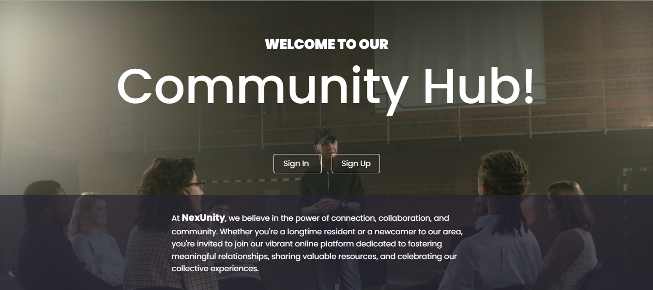

* **Sign Up page :**

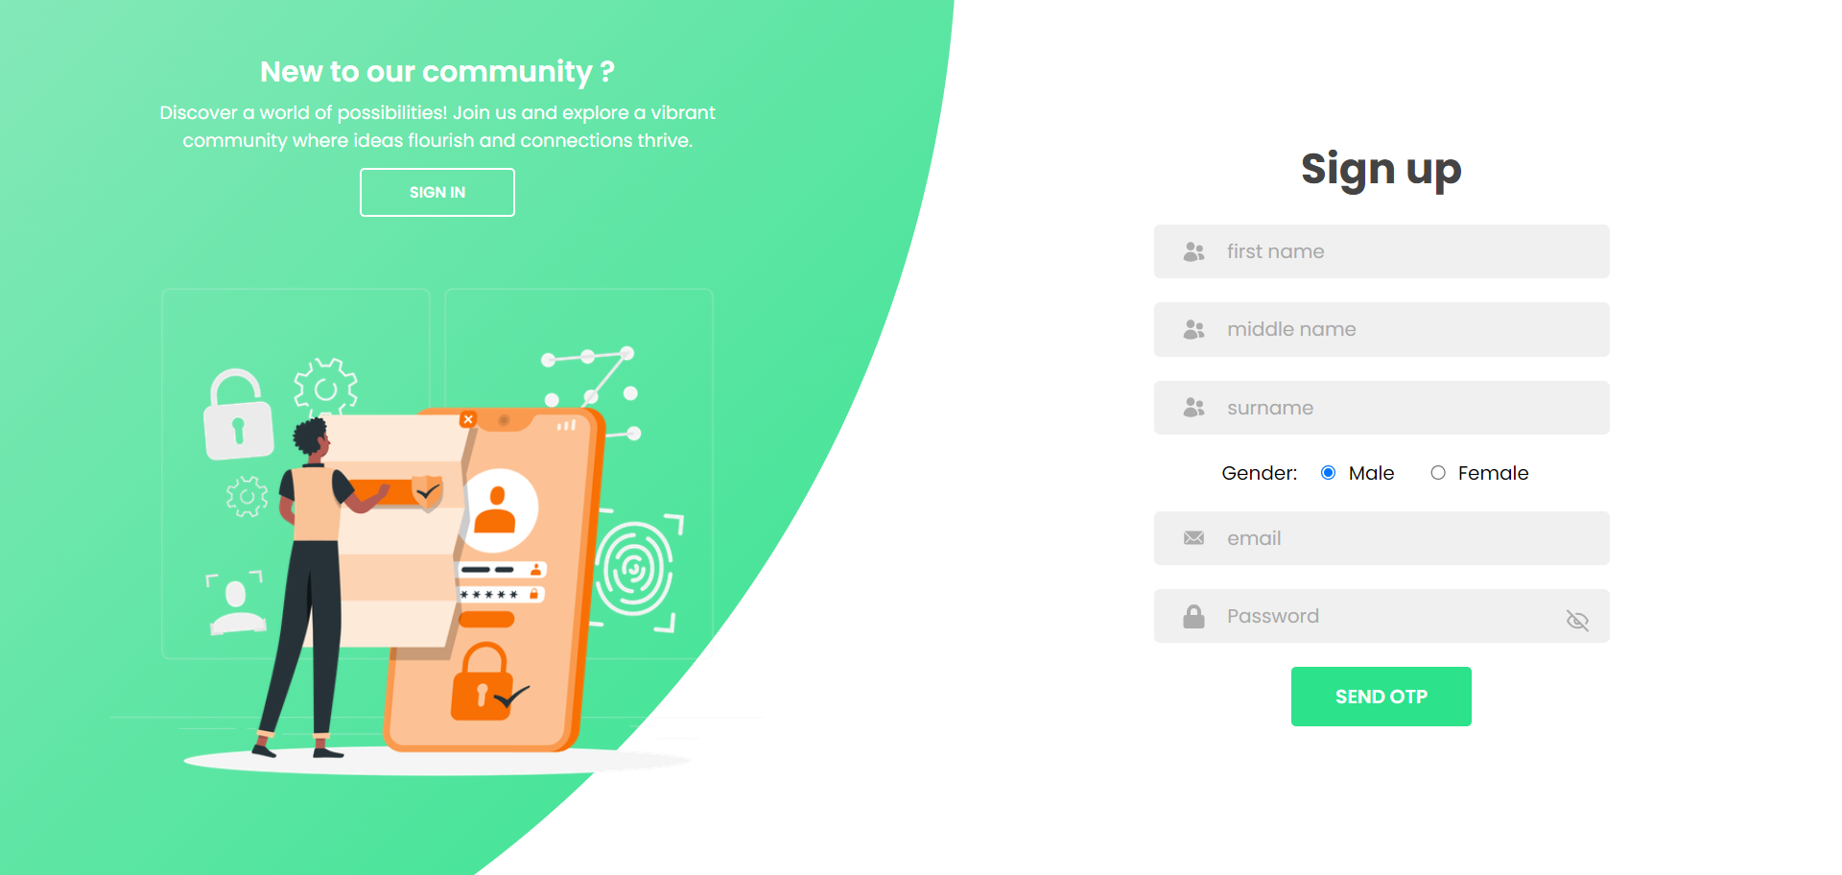

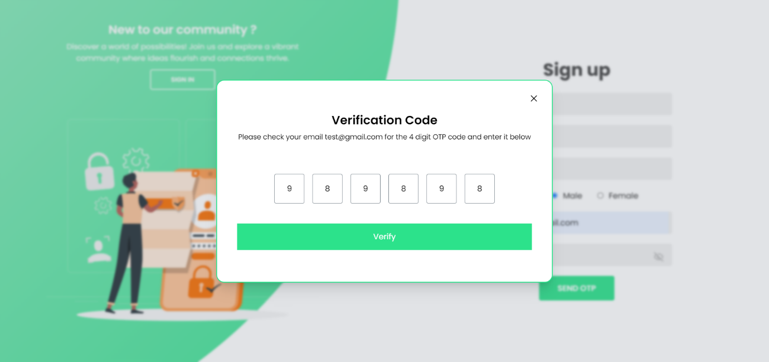

* **SignIn Page :**

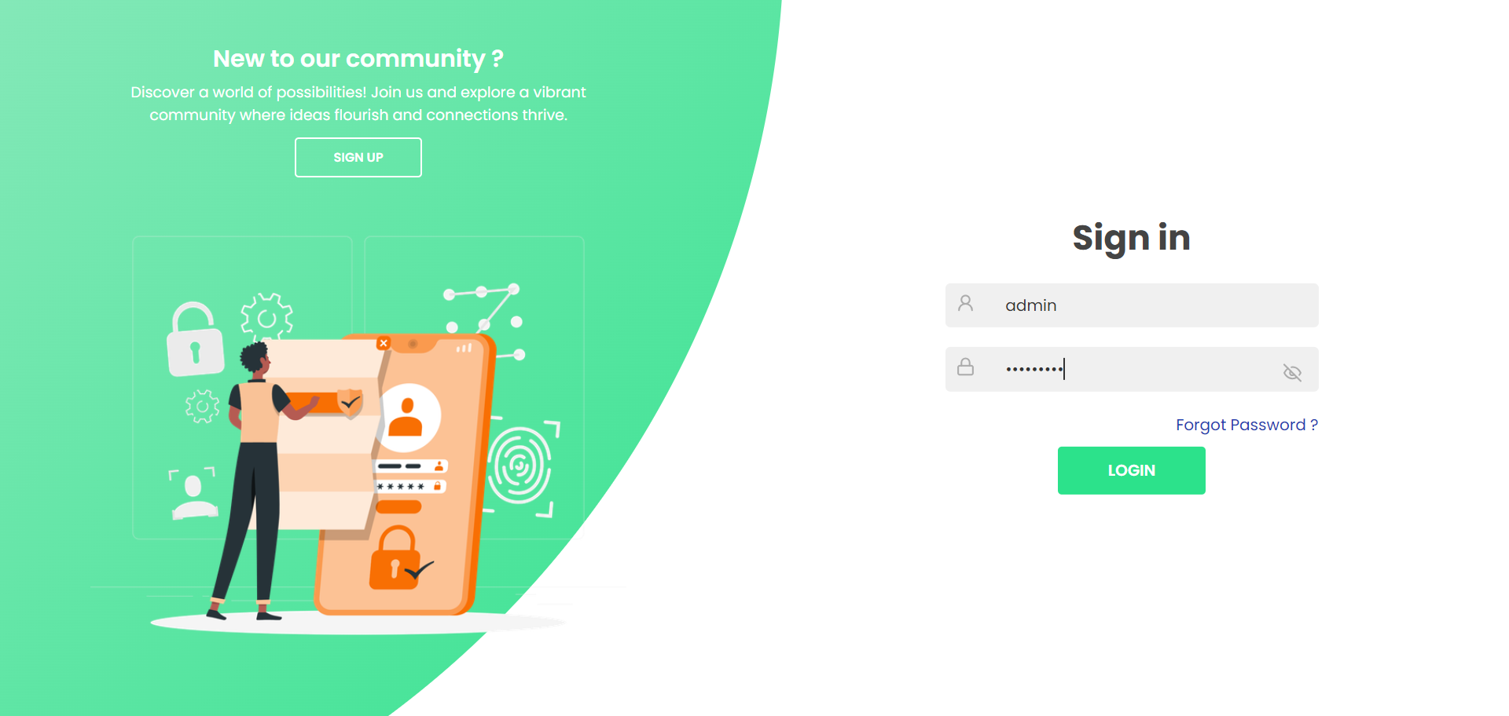

* **Forget Password :**

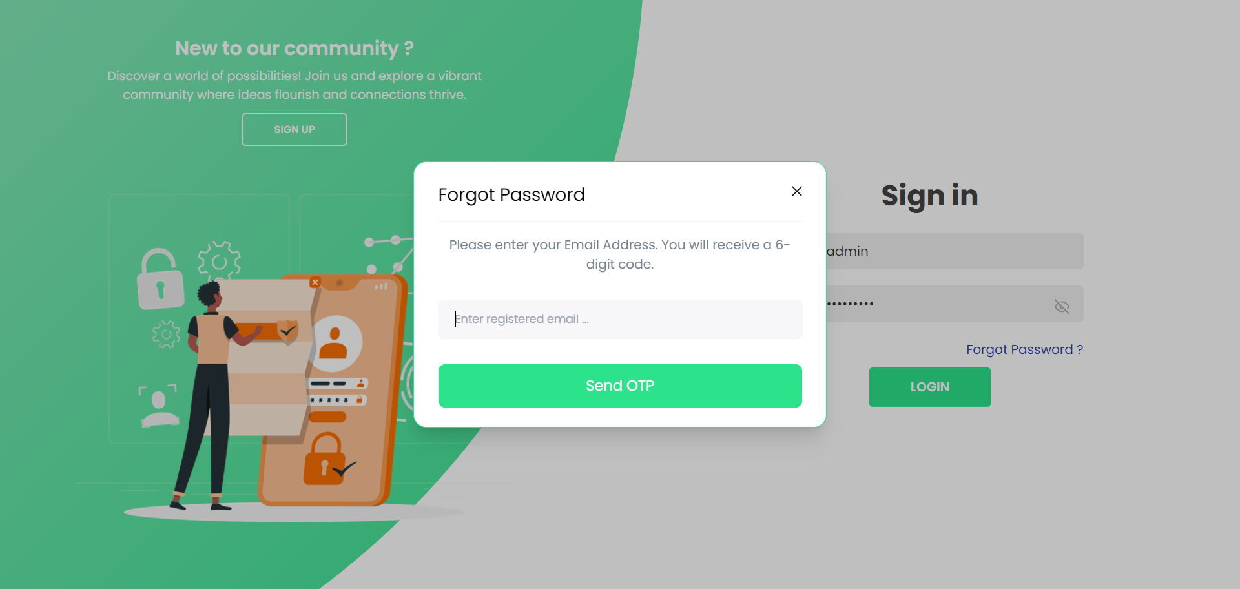

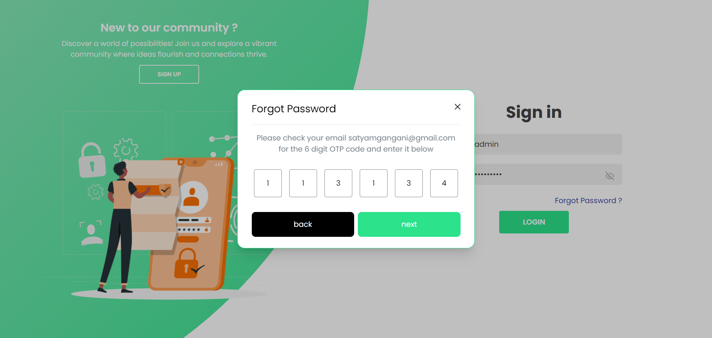

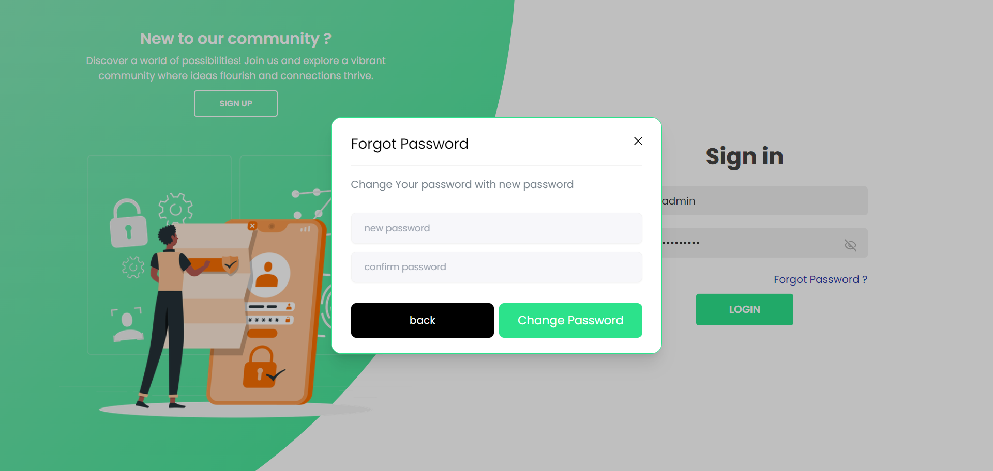

* Admin Site :

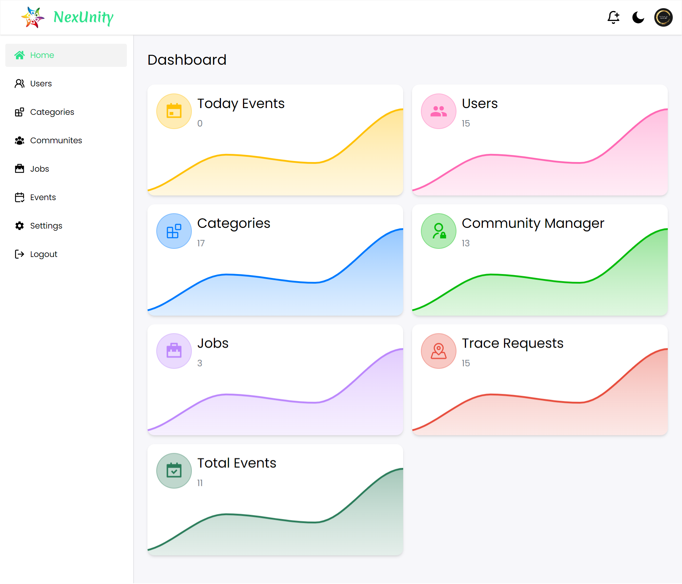

* **Category Page ( Admin) :**

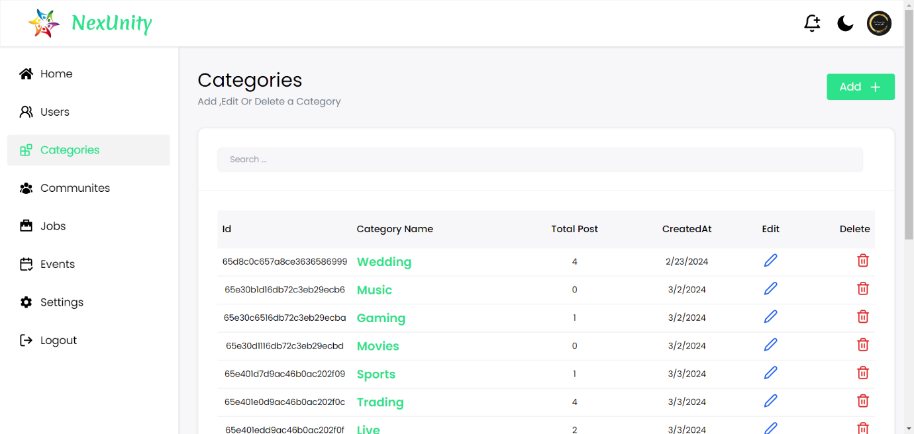

* **Add Category :**

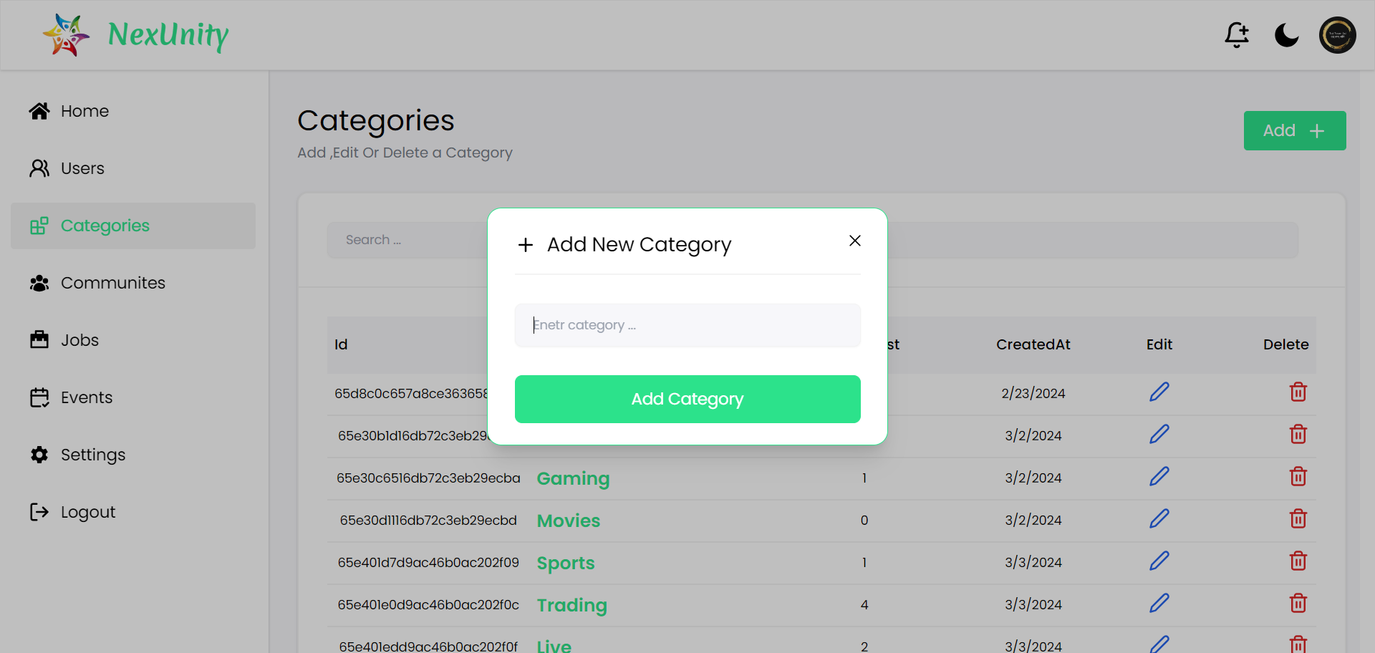

* **Update Category :**

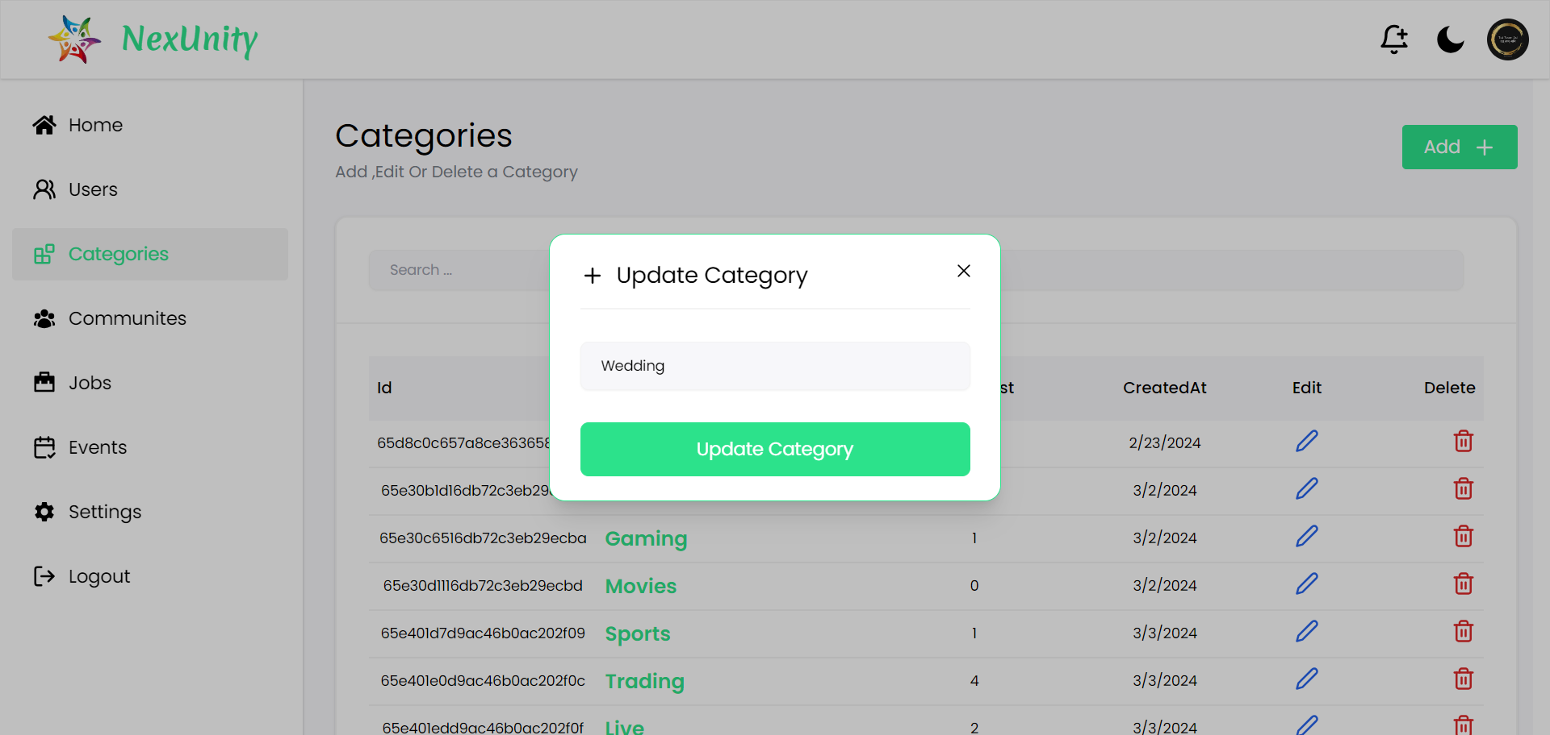

* **Delete Category :**

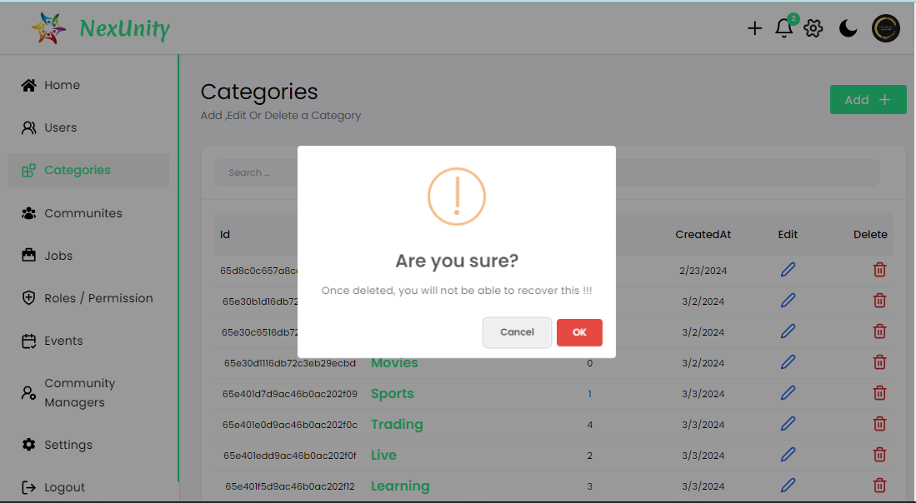

* **Community Page (Admin) :**

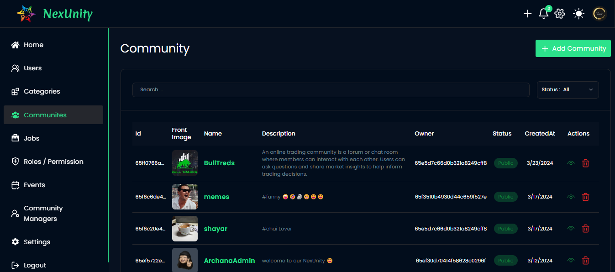

* **Community Filter :**

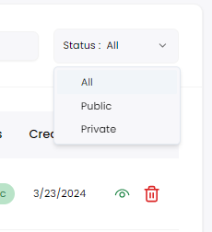

* **Event Page :**

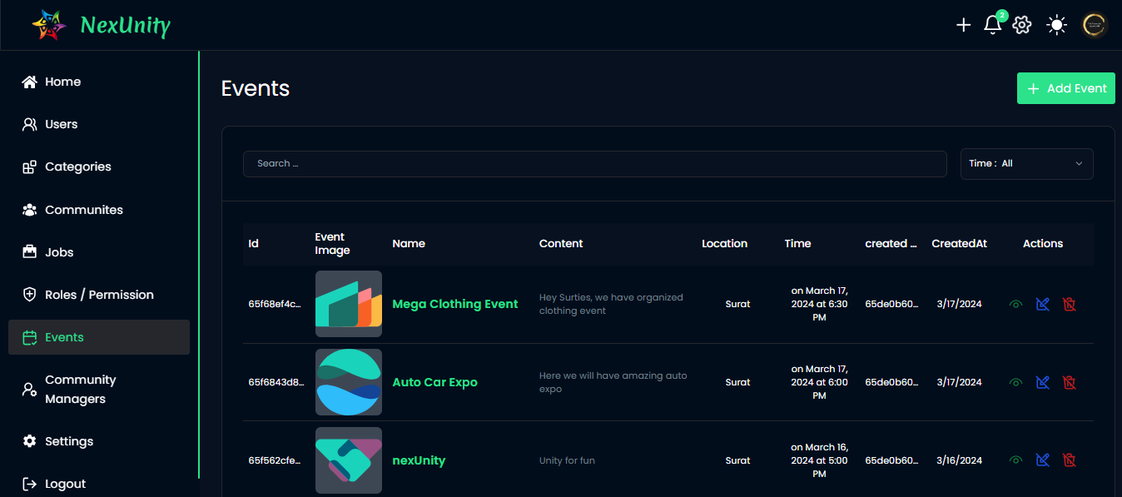

* **Add Event :**

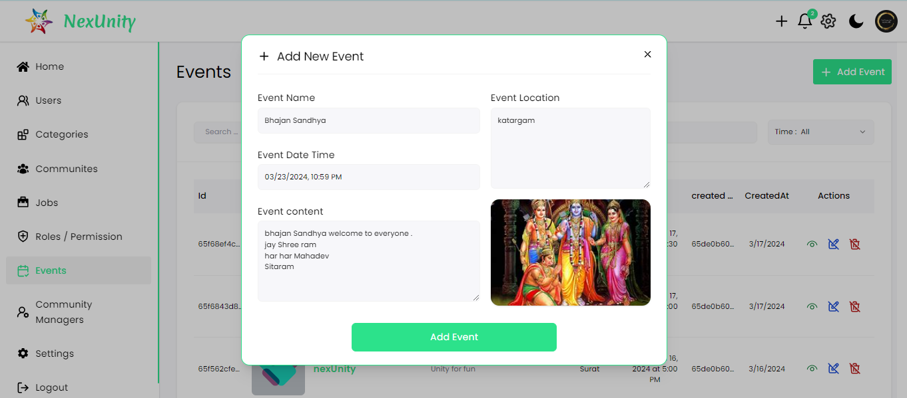

* 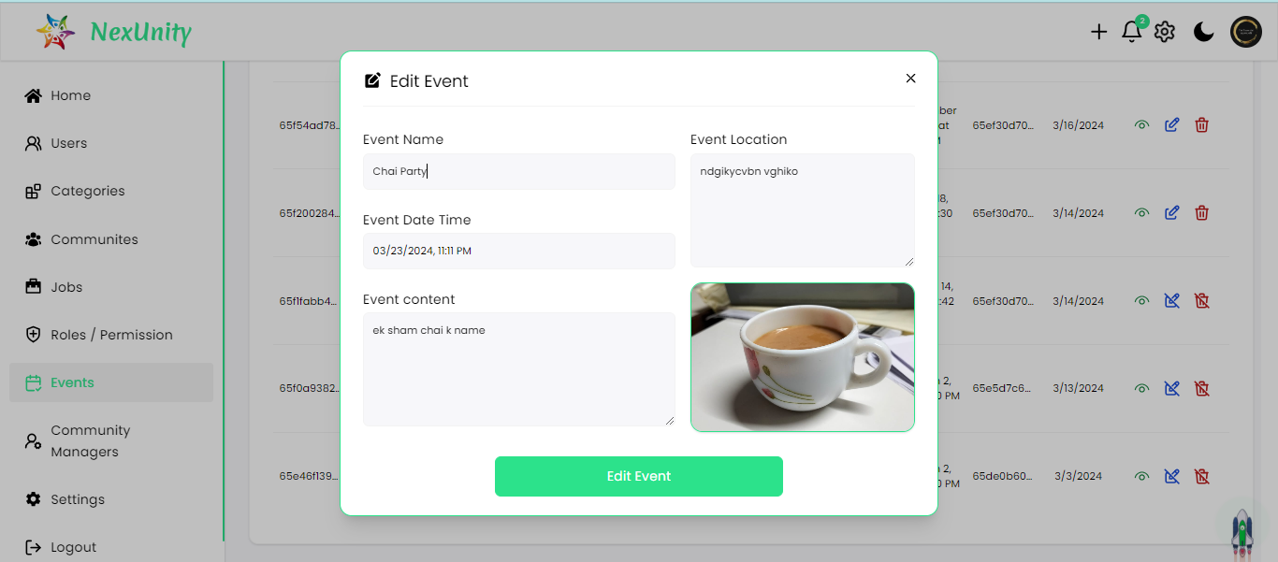 **Update Event :**
* 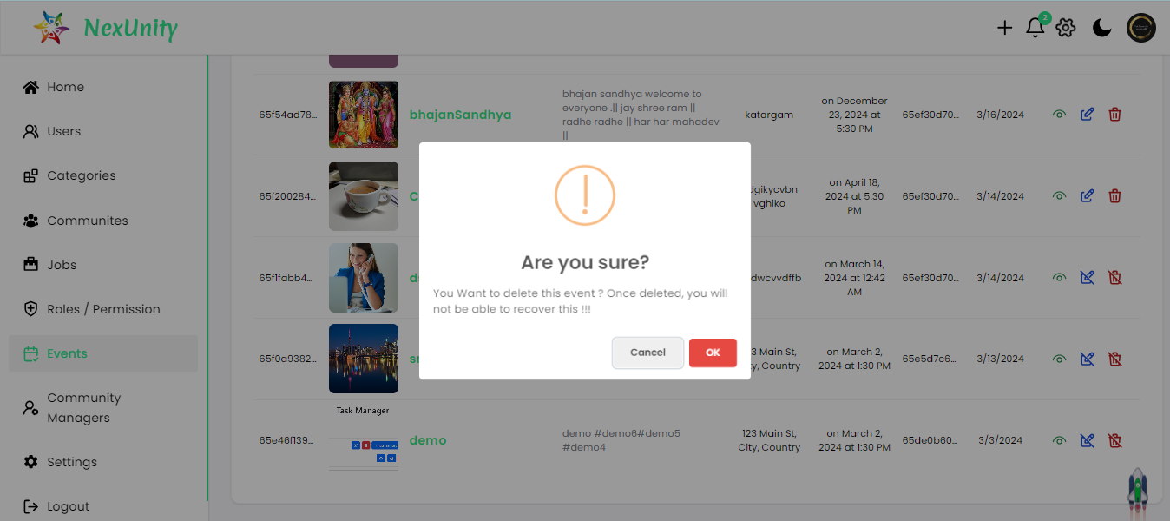 **Delete Event :**
* **Event Filter :**

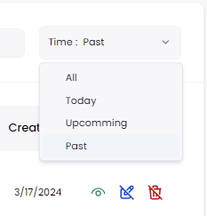

* **Job Page :**

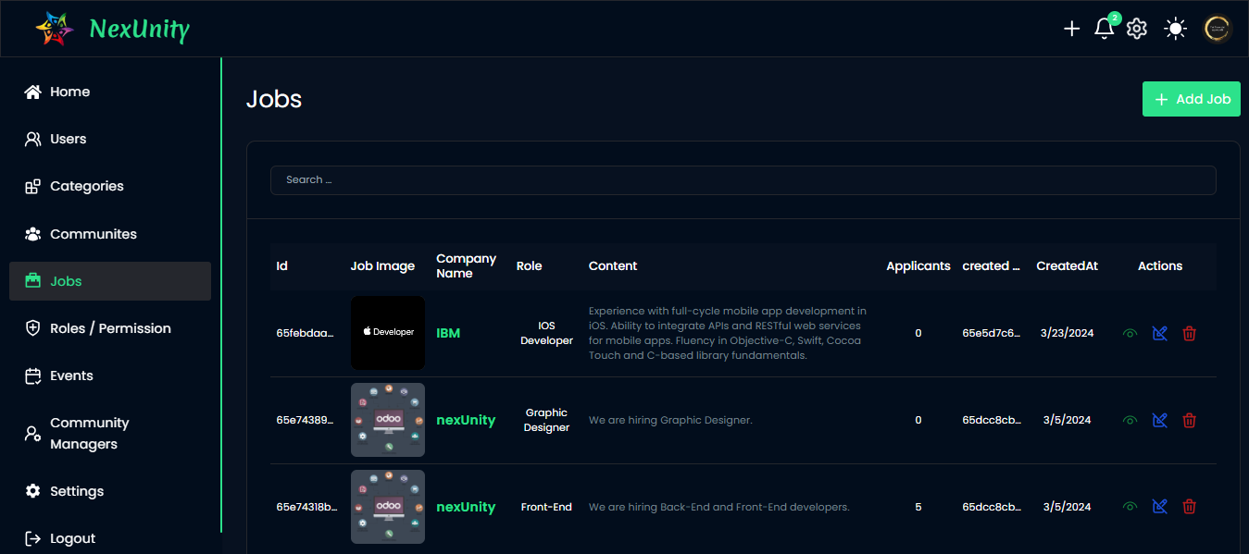

* **User Page (Admin) :**

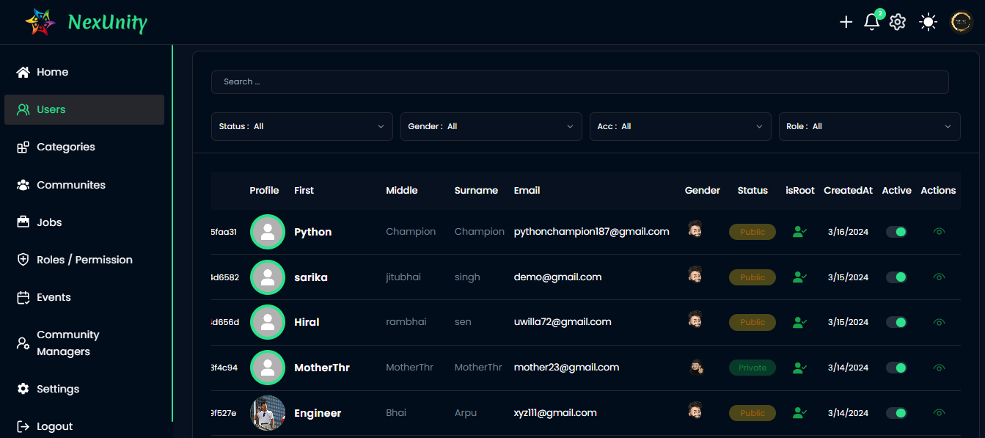

* **User Page Filter :**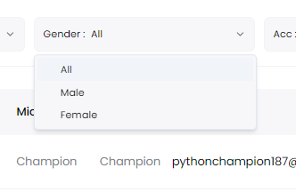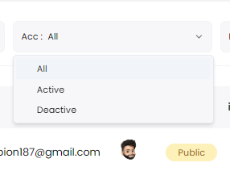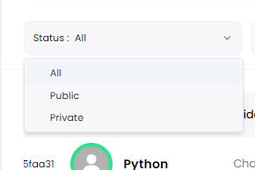

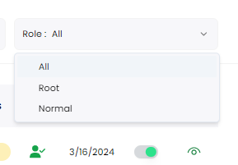

* **User Site :**

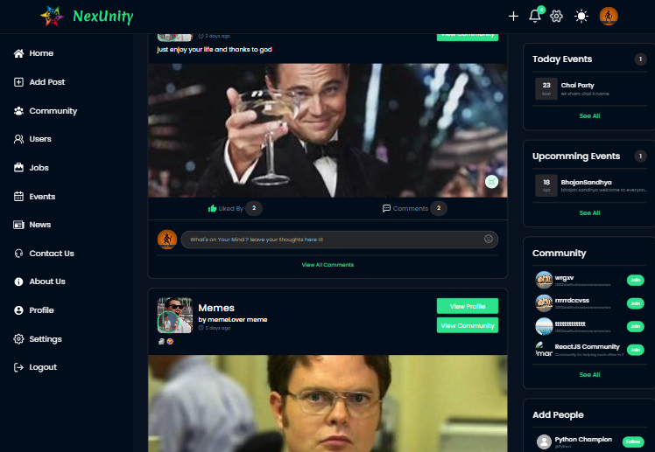

* **Users Page Profile (User):**

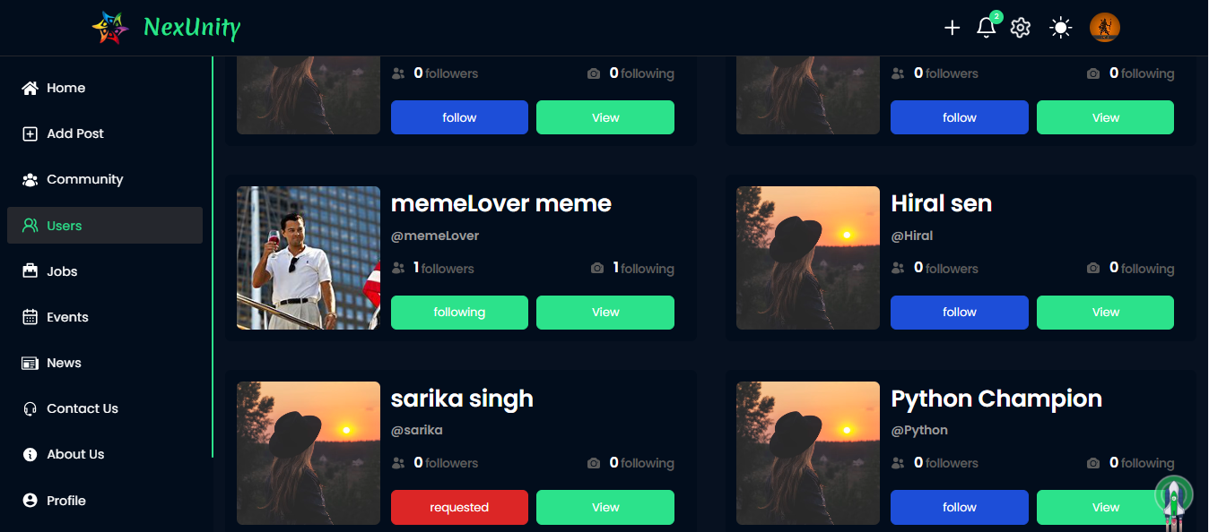

* **Single User Profile :**

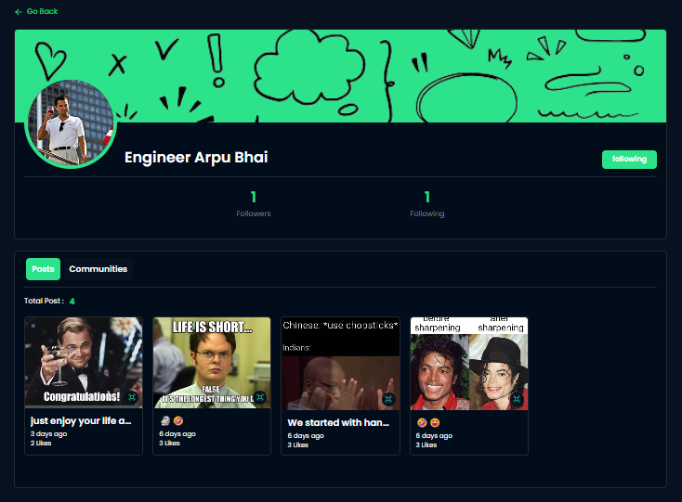

* 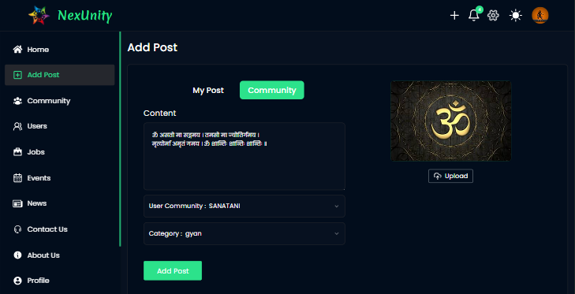**Add Post ( In Community ) :**
* **Add Post ( Personal ) :**

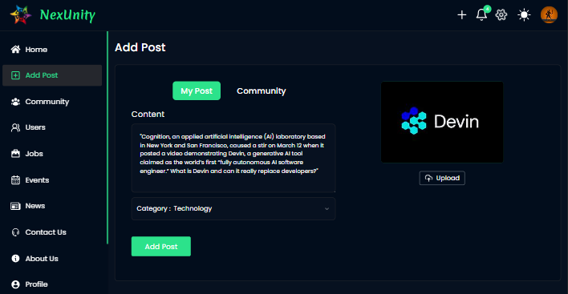

* **Create Community ( User ):**

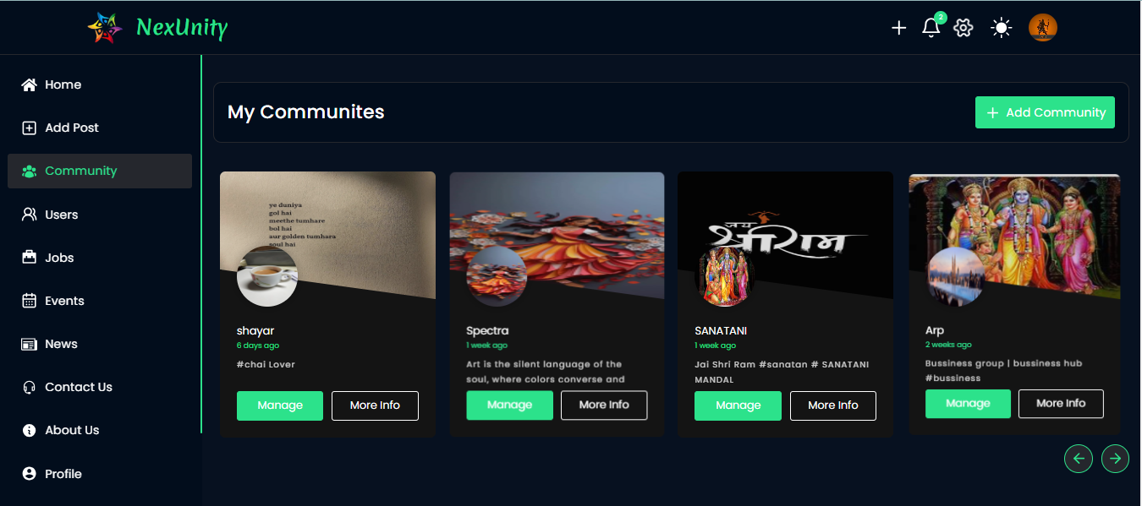

* **Joint Community :**

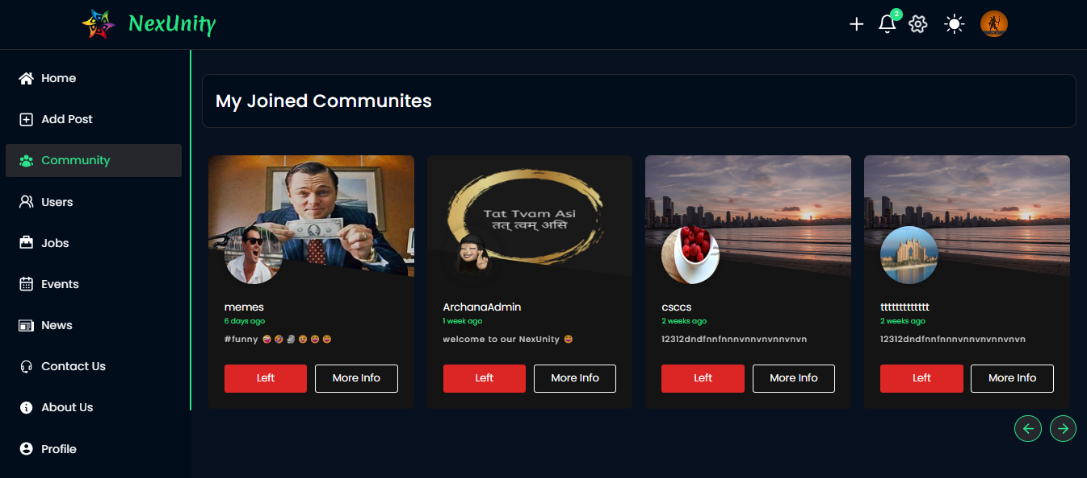

* **Other Community :**

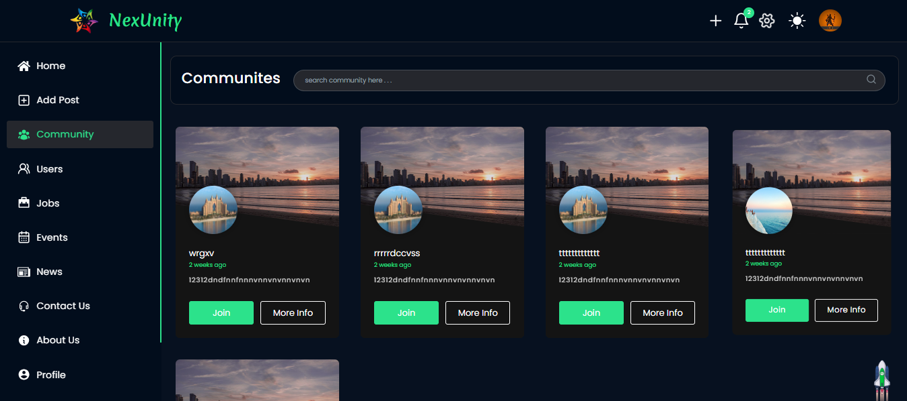

* **Single Community :**

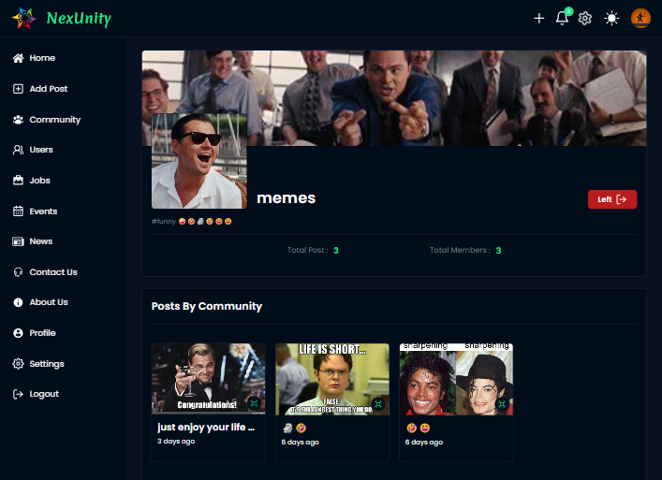

* **Logged In User ( Created Community Detailed ) :**

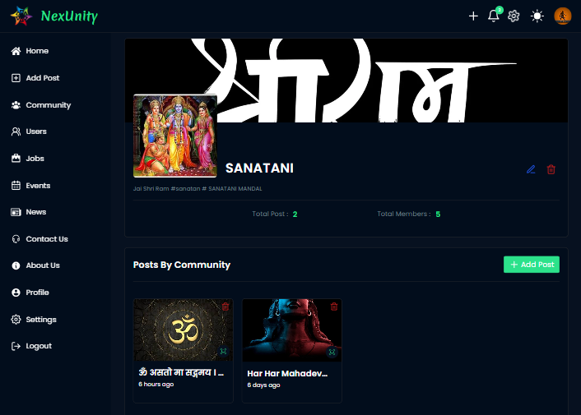

* **Jobs Page :**

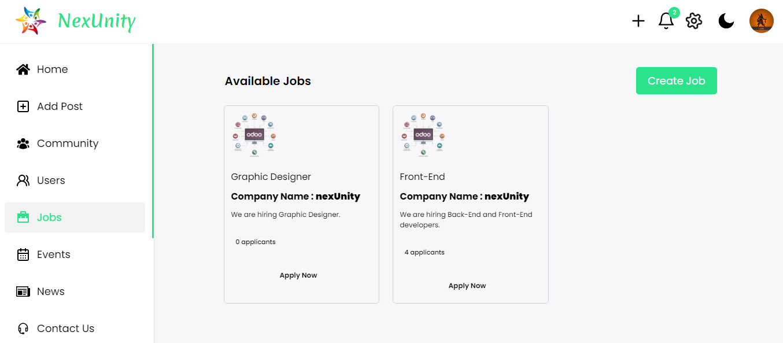

* 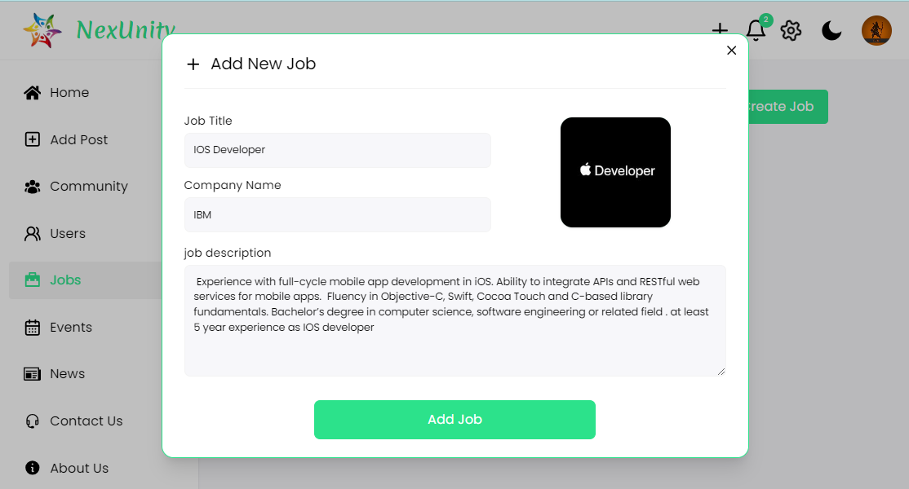 **Add Job :**
* **Edit Job :**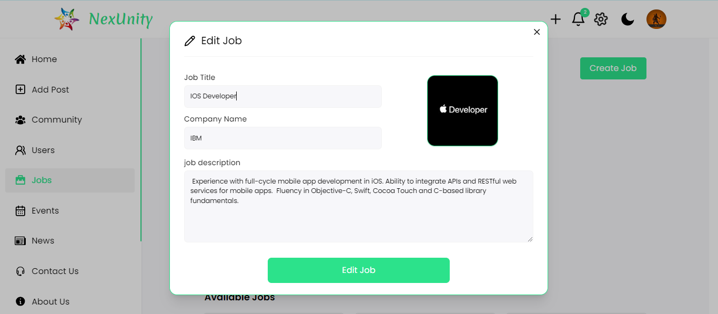
* **Delete job :**

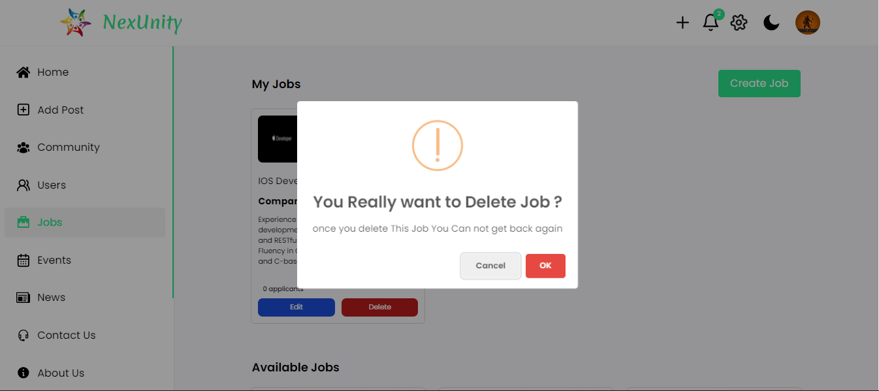

* 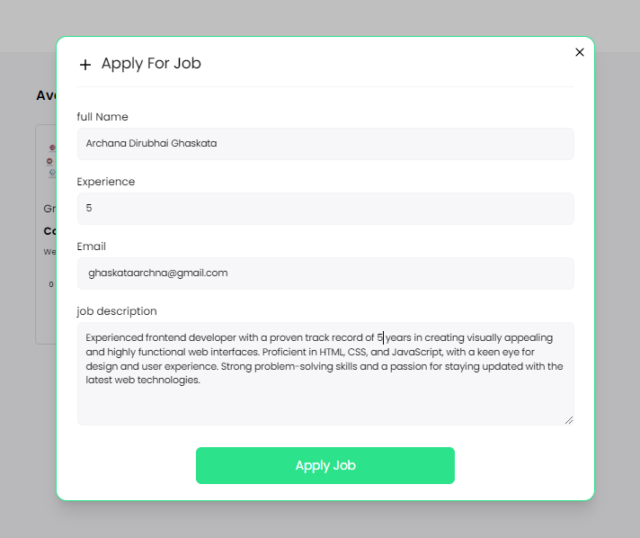 **Apply Job :**
* **Events Page :**
* **Single Event :**

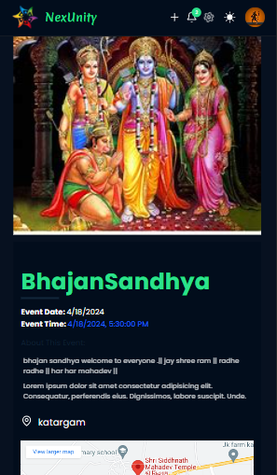

* 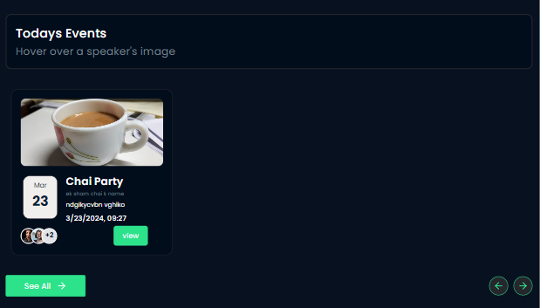 **Today’s Event :**
* **Upcoming Events :**

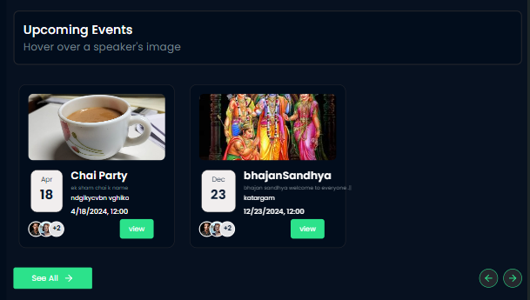

* **Past Events :**

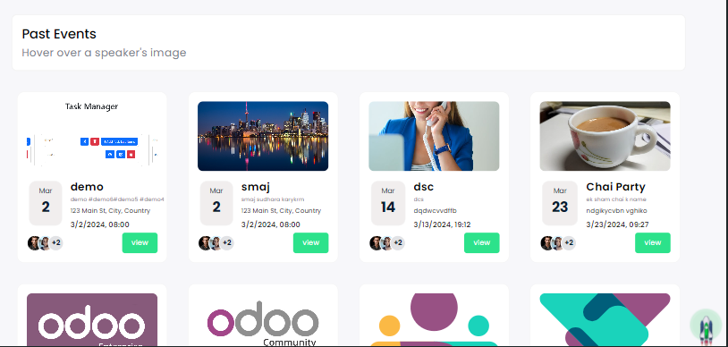

* **News Page :**

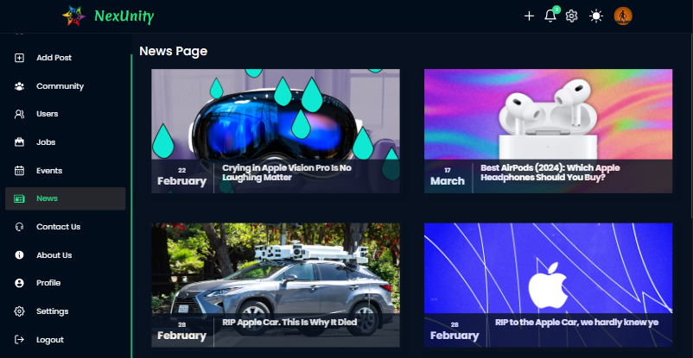

* **Contact Us Page :**

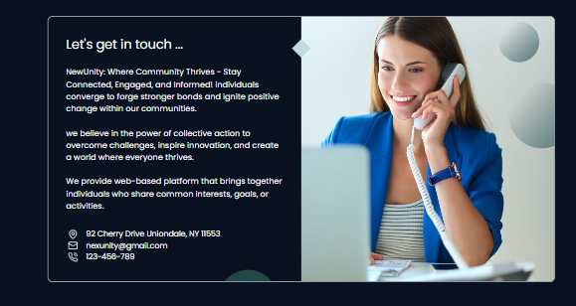

* **About Us Page :**

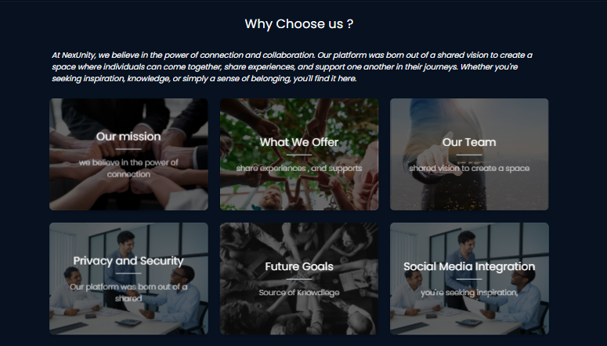

* **Notification ( User ) :**

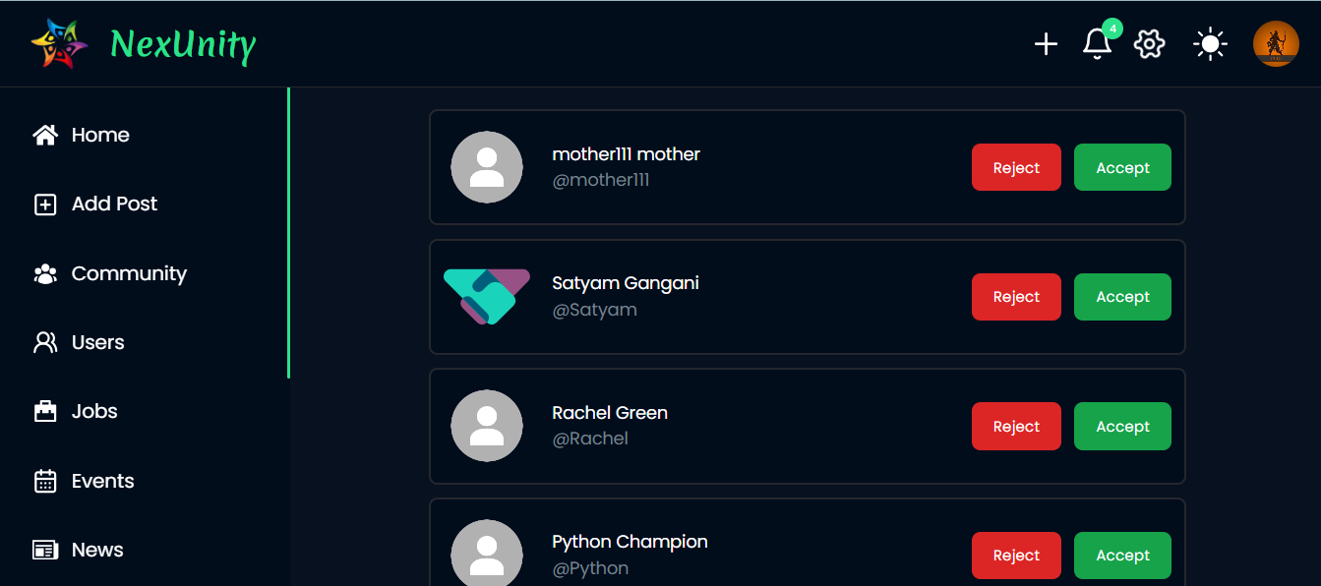

* **Extra functionality of Post :**
* **Community Post :**

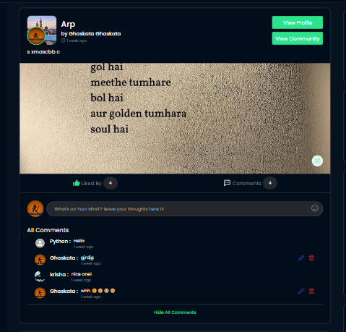

* 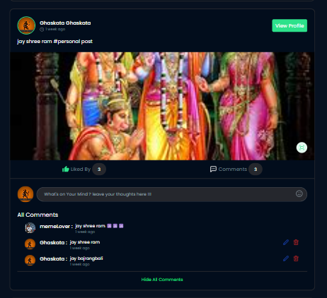**Personal Post :**
* 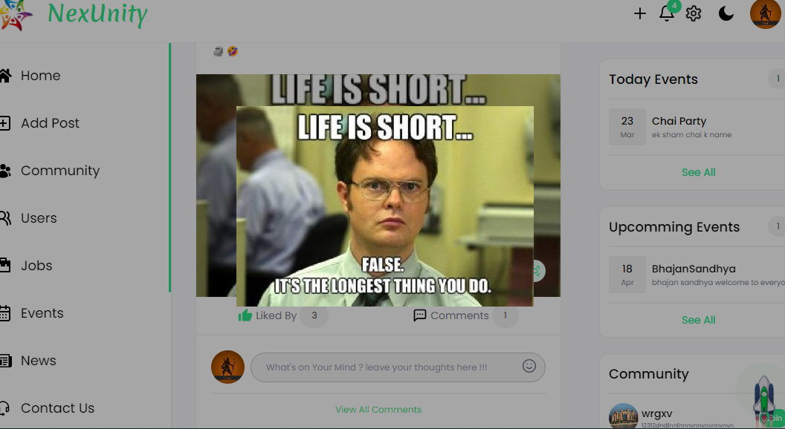**View Image ( Full Screen ) :**
* 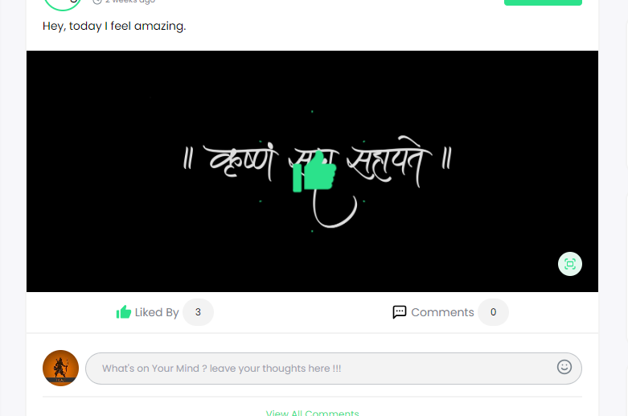**Like Post :**
* **Edit & Delete Comment :**

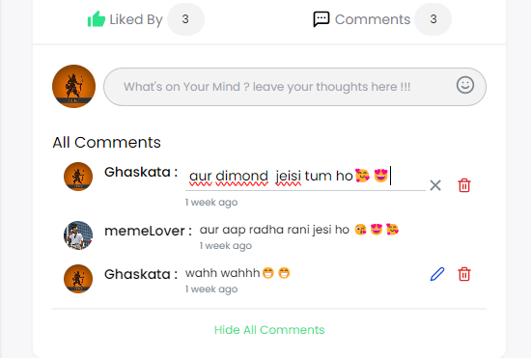

* **Profile Setting :**

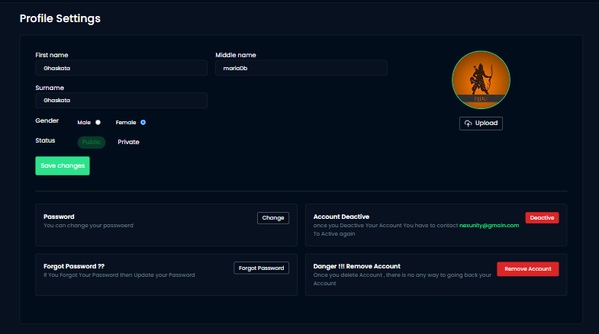

* 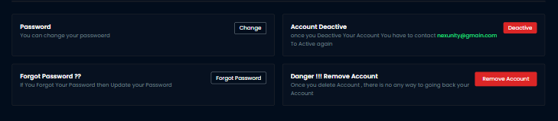**Account Related Advanced Settings :**
* **Account Related Advanced Settings :**

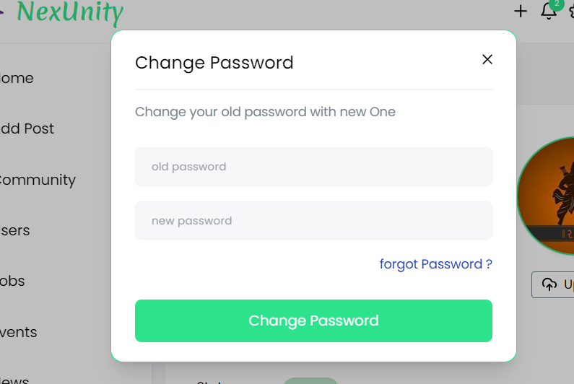

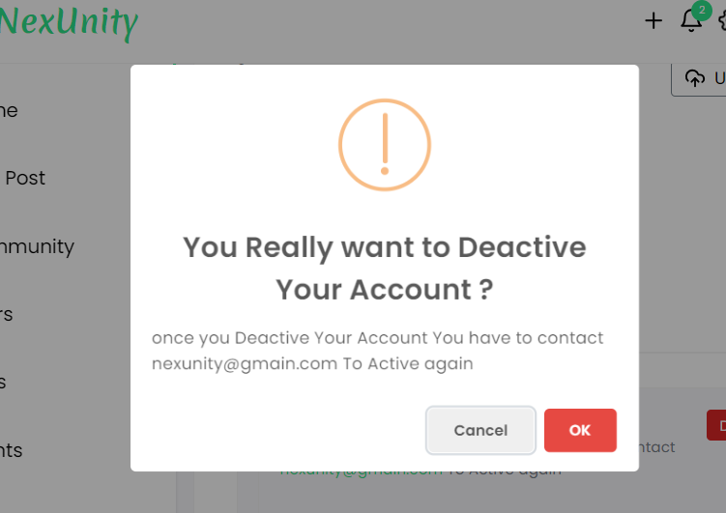

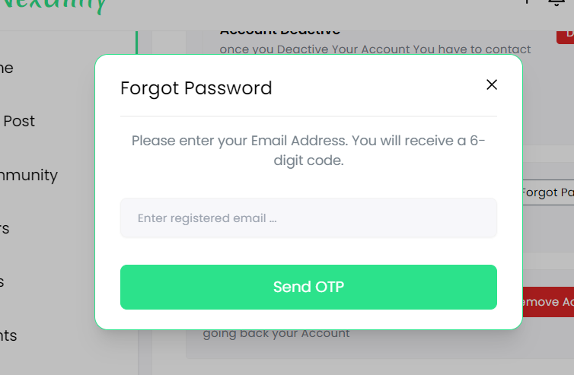

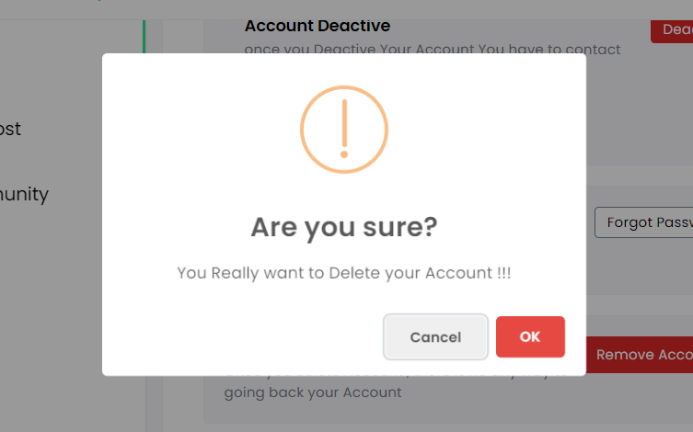

* 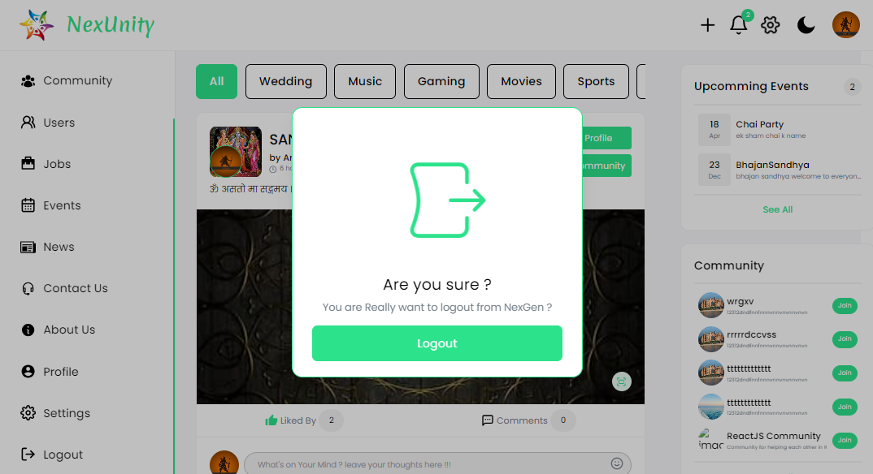 **LogOut :**

|  |
| --- |
| ***7. Software Testing*** |

* **Login :**

|  |  |  |  |
| --- | --- | --- | --- |
| **Test Field** | **Test Data** | **Valid/Invalid** | **Test Result** |
| **Email** | Empty | Invalid | Please Enter email address |
|  | 2332 | Invalid | Must be valid email |
|  | 123@gmail. | Invalid | Email must be valid email |
|  | test1@gmail.com | Valid | Valid input |
| **Password** | Empty | Invalid | Fill all the fields |
|  | asd | Invalid | Invalid credentials |
|  | Admin@123 | valid | Valid input |

* **Registration :**

|  |  |  |  |
| --- | --- | --- | --- |
| **Test Field** | **Test Data** | **Valid/Invalid** | **Test Result** |
| **First Name** | Empty | Invalid | Please fill all fields |
|  | 2332 | Invalid | First name must be valid |
|  | test | Valid | Valid input |
| **Middle Name** | Empty | Inalid | Please fill all fields |
|  | 2332 | Invalid | Middle name must be valid |
|  | Ora | Valid | Valid input |
| **Last Name** | Empty | Invalid | Please fill all fields |
|  | 2332 | Invalid | Last name must be valid |
|  | Patel | Valid | Valid input |
| **Gender** | not selected | Invalid | Fill all the fields |
|  | Male | Valid | Valid input |
|  | Female | Valid | Valid input |
| **Email** | Empty | Invalid | Please Enter email address |
|  | 2332 | Invalid | Must be valid email |
|  | test1@gmail.com | Valid | Valid input |

|  |  |  |  |
| --- | --- | --- | --- |
| **Password** | Empty | Invalid | Fill all the fields |
|  | asd | Invalid | Invalid credentials |
|  | Admin@123 | valid | Valid input |

* **OTP Verification :**

|  |  |  |  |
| --- | --- | --- | --- |
| **Test Field** | **Test Data** | **Valid/Invalid** | **Test Result** |
| **OTP verification** | Empty | Invalid | Please fill all fields |
|  | asasd | Invalid | Only numeric is allowed |
|  | 1234 | Invalid | OTP must contain 6 digit |
|  | 134613 | Valid | Valid input |

* **Forgot Password :**

|  |  |  |  |
| --- | --- | --- | --- |
| **Test Field** | **Test Data** | **Valid/Invalid** | **Test Result** |
| **Email** | Empty | Invalid | Please Enter email address |
|  | 2332 | Invalid | Must be valid email |
|  | test1@gmail.com | Valid | Valid input |
| **OTP** | Empty | Invalid | Please fill all fields |
|  | asasd | Invalid | Only numeric is allowed |
|  | 1234 | Invalid | OTP must contain 6 digit |
|  | 134613 | Valid | Valid input |
| **New Password** | Empty | Invalid | Fill all the fields |
|  | asd | Invalid | Password minimum 8 characters required |
|  | Admin@123 | valid | Valid input |
| **Confirm Password** | Empty | Invalid | Fill all the fields |
|  | asd | Invalid | Password minimum 8 characters required |
|  | Admin@12 | Invalid | Password must be same |
|  | Admin@123 | Valid | Valid input |

|  |
| --- |
| ***8. Limitations and Future Scope of Enhancements References*** |

* **Limitation :**
* Net connection requiring to run this system.
* It will take a time to send OTP on particular email address because using nodemailer authentication and human verification .
* It has also some limitations : Privacy issues , Fake news ,Cyber bullying , addiction , and many more .
* **Future Scope of Enhancements Reference:**

1. Making Friends:

* Let people follow each other to make connections and chat.

1. Likes and Comments:

* Allow users to like and comment on posts to show appreciation and start conversations.

3. Job Alerts:

* Notify users about job openings that match their skills or interests to help them find work.

4. Feedback and Help:

* Give users a way to share their thoughts and get support if they have problems.

5. Keeping Things Safe:

* Make sure posts and interactions follow the rules to keep the platform friendly.

6. Protecting Privacy:

* Keep user information safe and follow rules about privacy to build trust.
* **Reference :**
* <https://play.google.com/store/apps/details?id=com.commutree>
* <https://in.search.yahoo.com/search?fr=mcafee&type=E210IN826G0&p=instagram.com>
* <https://www.facebook.com>
* <https://www.reddit.com/?rdt=62947>
* <https://meta.discourse.org>